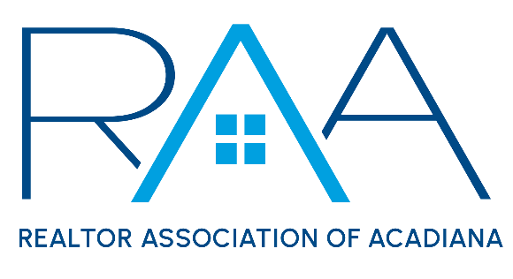
Board of Directors
September 23, 2025
9am/ RAA
MINUTES

I Call to Order: Ken Simeral, President called the meeting to order and verified a quorum had been achieved.

II Approval of Consent Agenda: A MOTION was made and seconded to approve the consent agenda for the September board agenda. MOTION CARRIED

II Acceptance of Financial Items : A MOTION was made and seconded to accept the financials as of August 31, 2025. MOTION CARRIED

IV Discussion Items:

- MLS: Christie House Theaux provided an update on ROAM MLS. It was discussed that staff work to do some marketing efforts on promoting to the membership on ROAM educational points. The CEO will take this recommendation to the staff.

- Update on the 2026 Elections: Erica Taylor, Chair of the 2026 Nominating Committee provided an update on the 2026 elections as well as on the mechanisms to fill the current vacated Out-of-Parish Seat.

- 2025 Awards Committee List: Simeral referred the board to his 2025 Awards Committee Nominations. A MOTION was made and seconded to approve the 2025 Awards Committee as presented. MOTION CARRIED

Simeral then referred to board members Task Force minutes for Renaming the Lloyd G. Smith Award. After reviewing the minutes the Board made a MOTION which was seconded to accept the recommendations from the task force regarding renaming the Lloyd G. Smith Award to the Cornerstone Award to allow

- 2026 Annual Budget Discussion and Approval: The board made the following motions regarding the 2026 Budget:

A MOTION was made and seconded to set the 2026 MLS Only fee to $675. MOTION CARRIED

A MOTION was made and seconded to authorize all recent fee increases to begin on January 1, 2026. MOTION CARRIED

- By-Laws Task Force: Simeral requested the board allow him to create a By-Laws Task Force to review the following items: Out-of Parish seat qualification, ROAM Board of Managers seat term limits and qualifications and the current RAA Election rules,

A MOTION was made and seconded to authorize

- October Board of Directors Meeting date: It was requested to move the October Board of Directors meeting date to Tuesday, October 28th at 9am. A MOTION was made and seconded to move the October meeting date to October 28th . MOTION CARRIED

- Clay Higgins Luncheon: Simeral remined the board of a special luncheon on Wednesday, September 24th from 11:45-2pm at the RAA Office.

- National Association of REALTORS®: Simeral reminded the board of the NAR NXT conference in Houston Texas, November 11-17th .

- Louisiana REALTORS® : Simeral reminded board members of the upcoming Louisiana REALTORS® Fall Governance meeting October 6-9th in Baton Rouge @ The Renaissance Hotel

V Strategic Thinking, Planning and Visioning:
While no topic was discussed it was suggested that a future topic be Private Listing Networks.

VI New/ Old Business:
Annual CEO review: Board members were reminded that they had received the CEO evaluation form. Erica Taylor, President Elect oversees the review process.

VII Upcoming Events: Simeral reviewed with the board the upcoming events for the Association. Tyler Rush pointed out YPN would have the October Morning Buzz on Thursday, October 9th at 8:30 am @ The Room at Corner Bar.

- Member Appreciation: Thursday, September 25th 11am-2pm
- RAA Annual Election: September 25th- October 1st / Election Committee to meet on Thursday, October 2nd.
- Gumbo Cook-off: Wednesday, October 23rd @ Parc International
- Leigh Brown’s 10 Tips you can Implement Now: Tuesday November 4th from 1:00-4:00 at LePavillon
- YPN Food Drive: Thursday, November 13th @ the ROOM @ Corner Bar
- YPN Morning Buzz: Thursday, December 11th The Naughty or Nice Edition 8:30am @ The Roo @ Corner Bar
- 2026 Board and Committee Chair Luncheon: Friday December 12th 11:30-1:30pm

With their being no further business the meeting was adjourned.

