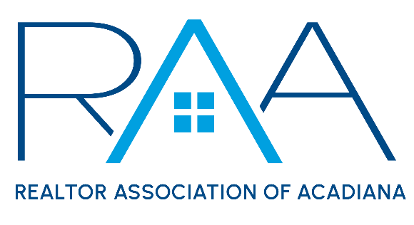
Board of Directors
May 20, 2025 9am/ RAA
MINUTES

I Call to Order: Ken Simeral, President called the meeting to order and established a quorum had been met.

II Approval of Consent Agenda A MOTION was made and second to approve the consent agenda as presented. MOTION CARRIED

- April 2025 Board of Directors Minutes
- MLS Committee Minutes ( May 2025)
- YPN Minutes ( May 2025)
- CEO report
- Membership recap report
- Board calls to new members
- Prudential Account balance as of April 30th $788,656.63

III Acceptance of Financial Items : Keisha Leblanc, Treasurer, opened the floor for any questions regarding the financials. She noted the International Potluck event cost about $1600.

A MOTION was made and seconded to accept the Treasurer’s report as presented. MOTION CARRIED

IV Discussion Items:

- MLS
- Roam Update: Christie Theaux provide the board with an update on ROAM MLS and an update to the way Coming Soon listing would syndicate from the MLS.
- Showingtime Update: The board reviewed and discussed transition issues from the Appointment Center product to the app only product. After a lengthy discussion the board instructed the CEO to request feedback on the product from the membership via the RAA Insider and to take this feedback to DC and meet with Showing time representatives during the conference.

- Opt out of RAA Roster Request from Gregory Reggie: Board members reviewed and considered a written request from RAA Member Gregory Reggie to make changes to the policy on members obtaining the membership roster. After a lengthy discussion no changes to the current Membership Roster policy will be made.

- National Association of REALTORS®: Simeral reported that he, Erica Taylor, Keisha LeBlanc and Jessica Lafitte Landry would be attending the NAR Legislative Meetings in Washington DC. It was requested that the RAA representatives meet with CRS data while in DC to have an update on tax data issues with Iberia parish.

- Louisiana REALTORS® : The board discussed the recent Louisiana REALTOR® conference in Baton Rouge.

V Strategic Thinking, Planning and Visioning: The board discussed the differences between servicing REALTOR® members and Non-REALTOR® members via ROAM MLS.

VI New/ Old Business:
- RAA Properties: Simeral reported the landscaping project was completed.

VII Upcoming Events:
- RAA Membership Appreciation Event: Tentative date is Fall 2025
- YPN Morning Buzz: Thursday, June 12th 8:30am @ The Room at Corner Bar
- YPN CornHole Tournament: Thursday July 17th @ The Madison in Broussard

With no further business the meeting was adjourned.

