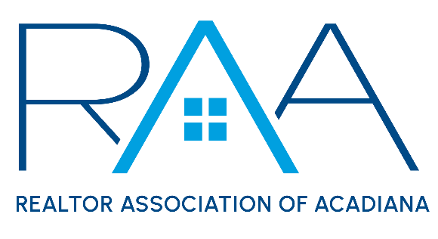
Board of Directors
June 24, 2025 | 9:00 a.m. | RAA
MINUTES

I Call to Order: Ken Simeral, President called the meeting to order and established a quorum had been met.

II Approval of Consent Agenda A MOTION was made and second to approve the consent agenda as presented. The BOD wanted it to be notated that they recognize that the dollar amount presented for the affiliate ticket to Leigh Brown’s event has not been finalized. MOTION CARRIED

- May 2025 Board of Directors Minutes
- MLS Minutes (NO meeting in June)
- YPN Minutes (June 2025)
- Cultural Diversity Minutes (May 20th)
- Professional Development (June 10)
- CEO report
- Membership recap report
- Board calls to new members
- Prudential Account balance as of May 31st is $797,455.27

III Acceptance of Financial Items : Keisha Leblanc, Treasurer, opened the floor for any questions regarding the financials.

A MOTION was made and seconded to accept the Treasurer’s report as presented. MOTION CARRIED

IV Discussion Items:

- MLS
- Roam Update: Christie Theaux provide the board with an update on ROAM MLS. Christie highlighted that ROAM has hired Mitch Skinner as their attorney, discussion regarding ROAM taking over the feeds, moving to a single system, integrating the SSO dashboard, Listing Integrity and it’s function within the MLS, and the lawsuit.
- RAA Attorney Jeremy Hebert was also present and gave the BOD an update regarding the lawsuit and examples of what could happen moving forward.
- RentSpree Integration: Amber Miller updated the BOD on the integration with RentSpree which should be incorporated in the MLS by the end of July 2025.

- Kim LaFleur’s resignation.

A MOTION was made to accept Kim LaFleur's resignation. MOTION CARRIED.

A MOTION was made to move Latonia Riggs from the Alternate Seat to Director for the remainder of 2025. MOTION CARRIED.

- Report from 2026 Nominating Committee: The timeline was shared for nominations and the election.

- National Association of REALTORS®: Simeral reported that he, Erica Taylor, Keisha LeBlanc and Jessica Lafitte Landry attended the NAR Legislative Meetings in Washington DC. Ken updated the BOD on RAA’s meetings with ShowingTime, Supra, and CRS Tax. Ken also mentioned that RAA will be working with NAR for a Grant in Lafayette.

- Louisiana REALTORS® : Simeral reported on the Legislative update regarding MLS Sales Tax. It was noted that while not a total win this would make the sales tax process a little easier on the RAA staff.

V Strategic Thinking, Planning and Visioning: No topic for June.

VI New/ Old Business: None

VII Upcoming Events:
- RAA Pride Event: Thursday, June 26^{th,} 4-6 pm @ The Library Downtown
- RAA Office Closed: 4th of July Holiday
- Property Management Committee: Tuesday, July 15^{th,} 11:30 am @ RAA
- YPN Cornhole: Thursday July 17th The Madison in Broussard
- YPN Morning Buzz: Thursday, August 14^{th,} 8:30 am @ The Room at Corner Bar
- CE Caravan: St. Landry Parish- Thursday, August 28th at SLED office
- Joint Industry Luncheon: September 11th from 11:30-1 pm at LePavillon featuring Matt Stuller
- Member Appreciation: Thursday, September 25^{th,} 11 am-2 pm @ Acadiana Lanes
- Gumbo Cook-off: Wednesday, October 23rd @ Parc International
- Leigh Brown’s 10 Tips you can Implement Now: Tuesday, November 4th from 1:00-4:00 at LePavillon

With no further business the meeting was adjourned.

