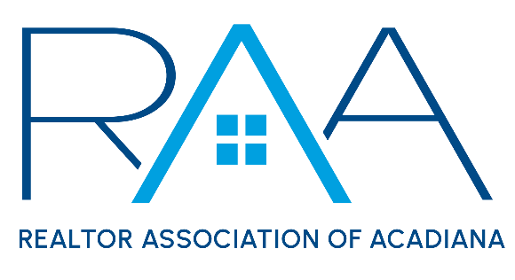
Board of Directors
July 22, 2025 9am/ RAA
MINUTES:

I Call to Order: Ken Simeral, President called the meeting to order and noted the following absences: John Ray Perkins, Latonia Riggs and Christie Theaux

II Approval of Consent Agenda: A MOTION was made to approve the Consent Agenda as presented with the exception of the MLS Committee Minutes. MOTION CARRIED.

After a lengthy review and discussion of the MLS Committee minutes for July a MOTION made and seconded to approve the MLS Committee minutes from July as presented. MOTION CARRIED

III Acceptance of Financial Items : A MOTION was made and seconded to accept the July 2025 Financials. MOTION CARRIED

IV Discussion Items:

- MLS: Susan Holliday, CEO provided a ROAM Board of Managers Update. She also provided an update on continued conversation with Showingtime.

- Report from the 2026 Nominating Committee: Erica Taylor, RAA President elect provided an update on the 2026 Nominating Committee.

- 2026 Election Committee Approval: A MOTION was made and seconded to approve the following members to serve on the 2026 Election Committee: Lisa Roy Sheppert, Reid Smith and Kelly Streva. MOTION CARRIED

- REALTOR Relief Fund (RRF) Contribution on 2026 Dues Invoice: A MOTION was made and seconded to approve a $10 voluntary / optional contribution be added to the 2026 Dues billing. MOTION CARRIED

- YPN Cornhole Update: Tyler Rush reported the recent YPN Cornhole tournament was a success and made a few dollars more than the 2024 event.

- National Association of REALTORS®: Simeral reported on the dates for the upcoming NAR NXT Conference which will be held November 11-17th in Houston Texas.

- Louisiana REALTORS®: Simeral referred the board to the included Louisiana REALTOR® upcoming fall Governance agenda.

The board made a MOTION to cover conference registration costs, 1 night stay for those wanting to attend the governance portion of the conference and a 2 night stay for those members who purchase with their own funds a ticket to the installation event for incoming Louisiana REALTOR® President Ginger Maulden. MOTION CARRIED

V Strategic Thinking, Planning and Visioning: RAA Financial Position and 2026 Draft Budget: Keisha Leblanc Treasurer. Leblanc did an in-depth presentation on the current financials for RAA and RAA Properties and presented a draft budget for 2026. A robust discussion ensued regarding the 2026 budget projections. Leblanc and staff will work with the Budget and Finance team and come back to the RAA board in August with options for the 2026 budget.

VI New/ Old Business:

VII Upcoming Events: Simeral reviewed with the board the upcoming events for RAA.
- Legislative Update Lunch featuring Natalie Cooper, Assistant Governmental Affairs Director for Louisiana REALTORS® Monday, August 4th at noon at RAA. Lunch to be provided. Seating limited to 65 people.
- AI in Real Estate Workshop with Ory Comeaux: Wednesday, August 13th at 1pm at the RAA Office
- YPN Morning Buzz: Thursday, August 14th 8:30am @ The Room at Corner Bar
- ACPAT Major Investor Brunch: Thursday, August 14th from 10am-noon at the Zuschlag Family Park
- 2026 Nominating Committee: Monday, August 18th at 11:30am @ the RAA Office
- LEDA/ RCA Breakfast Series: Wednesday, August 27th 8:30am at LEDA
- CE Caravan: St. Landry Parish- Thursday, August 28th at SLED office
- RAA Office Closed: Monday September 1st for Labor Day
- Power of Using your Network in Deals with Drake Abshire: Thursday September 4th @ 1pm at the RAA Office
- AMLA Fight Night: Thursday, September 4th @ The Room at Corner Bar
- YPN Morning Buzz: Thursday September 11th from 8:30am -9:30am @ The Room at Corner Bar
- Joint Industry Luncheon: September 11th from 11:30-1pm at LePavillon featuring Matt Stuller
- Member Appreciation: Thursday, September 25th 11am-2pm
- RAA Annual Election: September 25th- October 1st / Election Committee to meet on Thursday, October 2nd.
- Gumbo Cook-off: Wednesday, October 23rd @ Parc International
- Leigh Brown’s 10 Tips you can Implement Now: Tuesday November 4th from 1:00-4:00 at LePavillon

With no further business the meeting was adjourned.

