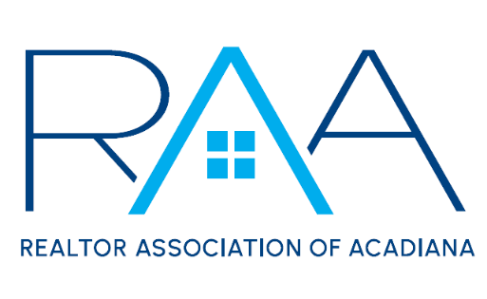
Events Committee Meeting
July 31, 2025
Minutes
- Call to Order: Sam Hayes and Elena Ladmirault, Event Chairs, called the meeting to order at 1:03 pm.
- Member Appreciation
  - Venue: The Yard Goat reached out to the staff with new pricing for the event. This was presented to the committee and after talking over the pros and cons for The Yard Goat and Premier Lanes there was a vote. Premier Lanes won the vote 12 to 8.
  - Date: The date is scheduled for September 25th from 11am to 2 pm at Premier Lanes.
  - Food: A Motion was made and passed for the RAA Staff to decide food options for this event.
- Gumbo Cook-Off
  - Theme: The Committee voted on a theme for the cook-off. Decades won by a landslide.
  - Tickets: A Motion was made and passed for children 10 & under to get in for free, for tickets to be $10 for presale and $15 day of, and at noon on the day of the event everyone must have a wristband or pay the $15 cover.
  - Booths: No extra tents will be allowed in the park for the cook-off. Home Bank will do the drinks and want to keep the same location as 2024.
- New Business: There was no new business
- With there being no further business, the meeting was adjourned at 2:03pm.

