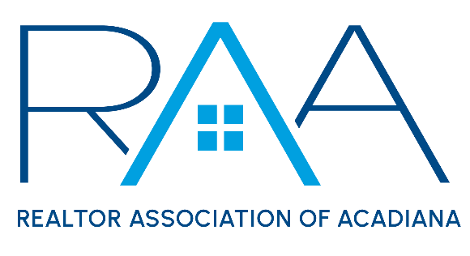
Board of Directors
August 26, 2025 9am/ RAA
MINUTES:

I Call to Order: Ken Simeral, President called the meeting to order noted absences and confirmed a quorum had been met.

II Approval of Consent Agenda A MOTION was made and seconded to approve the consent agenda. MOTION CARRIED

III Acceptance of Financial Items: A MOTION was made and seconded to accept the financial statements for the REALTOR® Association of Acadiana and RAA Properties. MOTION CARRIED

IV Discussion Items:

- MLS: Susan Holliday CEO provided the board with an update on ROAM MLS.

- Update from the 2026 Nominating Committee: Erica Taylor, Chair of the 2026 Nominating committee provided an update on the 2026 Nominations and election cycle.

- Legal Update: Susan Holliday, CEO provided an update on recent legal cases regarding REALTOR® membership requirement for MLS access.

- 2026 Annual Budget Discussion and Approval: The board began in an in-depth discussion on RAA finances, 2026 membership and budget projections.

A MOTION was made and seconded to accept the following recommendations from the Budget & Finance Committee with the exception of Affiliate dues rate being set at $150 beginning in 2026. MOTION CARRIED

The Budget and Finance Committee recommend the following:
- To raise new broker office fees from $500 to $600
- To increase annual Affiliate dues from $100 to $125
- To increase the reinstatement fee from $100 to $150
- To discontinue the MLS Fine Forgiveness class
- To decrease the Honor Society Budget to $3,000 thus eliminating the annual “gift” to members of the honor society
- To remove the $5,000 budgeted for REALTOR® Relief fund in anticipation of members contributing voluntarily to this fund via the 2026 dues invoice.
- To approve the staff to start a shopify store to sell RAA branded items.

A MOTION was made and seconded to raise MLS fees in 2026 by $4 per member per month or $600 annually. MOTION CARRIED

- National Association of REALTORS®: Simeral reported on the upcoming NAR conference, NXT Conference in Houston Texas, November 11-17th

- Louisiana REALTORS® : Simeral discussed with the board the upcoming Louisiana REALTOR® conference in October in Baton Rouge. Susan Holliday, CEO will re-send the registration link to anyone who is interested in attending.

V Strategic Thinking, Planning and Visioning: Item was deferred due to time constraints.

VI New/ Old Business: It was announced the annual CEO review would be launched soon. Erica Taylor, RAA President Elect would be in charge of the process. Board members would receive the review forms shortly.

Simeral reviewed with the board the Upcoming event for the Association.

VII Upcoming Events:
- LEDA/ RCA Breakfast Series: Wednesday, August 27th 8:30am at LEDA
- CE Caravan: St. Landry Parish- Thursday, August 28th at SLED office
- RAA Office Closed: Monday September 1st for Labor Day
- Power of Using your Network in Deals with Drake Abshire: Thursday September 4th @ 1pm at the RAA Office
- AMLA Fight Night: Thursday, September 4th @ The Room at Corner Bar
- YPN Morning Buzz: Thursday September 11th from 8:30am -9:30am @ The Room at Corner Bar
- Joint Industry Luncheon: September 11th from 11:30-1pm at LePavillon featuring Matt Stuller
- Member Appreciation: Thursday, September 25th 11am-2pm
- RAA Annual Election: September 25th- October 1st / Election Committee to meet on Thursday, October 2nd.
- Gumbo Cook-off: Wednesday, October 23rd @ Parc International
- Leigh Brown’s 10 Tips you can Implement Now: Tuesday November 4th from 1:00-4:00 at LePavillon

With no further business the meeting was adjourned.

