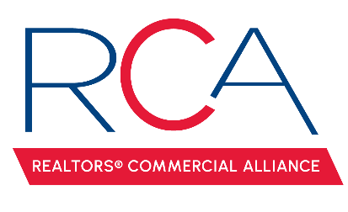

MINUTES

REALTORS® Commercial Alliance
Board Meeting
July 23, 2025

- Welcome & Introductions: Monty Warren, President, called the meeting to order.

- Approval of Minutes: A MOTION was made and seconded to approve minutes from the April 22, 2025 meeting. MOTION CARRIED

- Reviewed the account balance. It was noted that the current balance included some of the ACO income, but it does not include the membership dues for 2025. RCA donated $500 to Vermillion Catholic School in memory of Campbell Shepard, daughter of former board member Clinton Shepard.

- Membership Update: 194 Active REALTOR members, 16 Associate members, and 37 Affiliate members.

- LACDB Update: Amber Miller reported on the recent LACDB BOD meeting, where they discussed the LACDB Software Update. Software adoption and training has gone very smoothly with a few items needing to be resolved. It was reported that Lafayette had the second-highest attendance for training out of the state.

- RAA Update: Paul Arceneaux reported on the recent RAA BOD meeting. There was nothing of note that was commercial specific.

- CE Classes: Amber proposed a few education options.
  - LR is offering the Commercial Mandatory Alternative; however, this year, they are charging $45 per person. A MOTION was made and seconded that RCA will pay $25 per RCA member with an attendance cap of 50 members. The members will be responsible for covering the remaining $20. MOTION CARRIED.
  - Brent Lancaster has three commercial virtual classes that are 3 hours each. The board of directors requests that Amber see if Brent can condense one of the classes to a two hour option.

- LEDA Breakfast Series. Mark Mouton updated the board that our next event in the series will be August 27th and Municipality Mayors has been rescheduled to October 8th. Mark requested feedback from the board of any questions or information they would like to hear from Mandi, the LEDA staff, or the Municipality Mayors at the next two meetings.

- Calendar of Events: Amber updated the board on the attendance of our June Social at Corner Bar. A MOTION was made to have our next social at LaFonda’s on September 17th from 4-6 p.m. MOTION CARRIED. A MOTION was made to have the Board Installation on December 4th from 6 -8 p.m. Amber will work with Chad on a location. MOTION CARRIED.

- Elections. Amber reminded the board that nominations for elections will begin on October 13th. RCA will have President Elect, Treasurer, and two member at large seats available.

- Next Board Meeting: The next RCA Board Meeting will be October 1st at 11:30 a.m.
With no other business to discuss, the meeting was adjourned.

