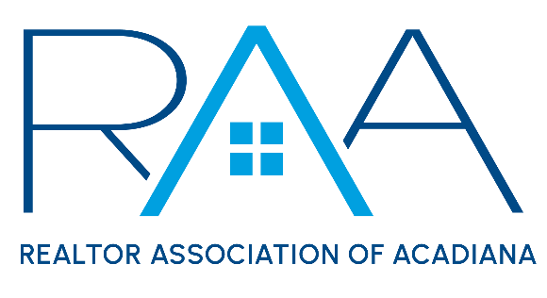
November 28th
9am/ RAA
Minutes:

I Call to Order: Jacquelyn Cain Gleason, President
- Absences/ Roll Call

II Approval of Board Minutes: A MOTION was made and seconded to approve the minutes from the October Board Meeting. MOTION CARRIED

III President’s Report:
- 2024 Billing: Gleason reviewed with members of the board the current renewals for the 2024 dues billing, noting collections are trending the same as the 2023 collections.
- MLS/ ROAM: Christie House Theaux provided a report on her attendance to the ROAM Strategic Planning session in Baton Rouge.
- NAR Meeting Update: Gleason reported on the officer’s attendance at the NAR meeting. Holliday reported on the status if the NAR insurance program through Chubbs. And the board discussed the recent RAA hosted town Hall at the Lite Center.
- Pipeline for Success: 3rd session Feedback: Gleason reviewed with board the recent attendee feedback for the 3rd Pipeline for Success.

- Louisiana REALTORS®: LR is hosting a Broker Zoom meeting on Wednesday, December 6th and Gleason encouraged board members to register and attend. The board discussed the upcoming Learning to Lead Conference for the 2024 Board members to attend.

A MOTION was made and seconded to fund the 2024 Board of Directors for the conference for a 2-night stay and conference registration costs. MOTION CARRIED

Louisiana REALTORS® will host a Region 2 Meeting: Wednesday, January 31st at the Doubletree on pinhook. Registration begins at 8am with Local BOD Training at 9am followed by a lunch at 11:30 and then Professional Standards Training 1-5pm which counts for 4 hours CE credit.

IV Treasurer’s Report: Ken Simeral provided the board with the Treasurer’s report. He noted the current membership number of and referred board members to the list of new members. He asked the board members to make their assigned calls to these new members. Simeral noted the investment account with Prudential was at $690,344.20 as of October 31st.

Simeral then reviewed with the board the current financials for the REALTOR® Association of Acadiana and RAA Properties. He reported on the lease renewals for RAA Properties.

Simeral Then referred board members to the Minutes from the Budget and Finance Committee.

V Committee Reports:
a. MLS: Angi Trahan( attached)
b. YPN: Keisha LeBlanc ( attached)
c. RCA: Caitlyn Williams (attached)

VI CEO Report:
- Staff

VII New/ Old Business:
- CE Designation Policy

VIII Upcoming Events:
- Installation of Christie House Theaux: Thursday, November 30th at Bridge Point farms 5:30-8:30pm
- AMLA Holiday Party: Thursday, December 7th at City Club @ River Ranch
- Broker Breakfast: Friday December 8th at 9am at the RAA Office
- 2023 Board and Committee Luncheon host by Jacquie Geason: Thursday, December 14th at Park Bistro ( 407 Brooke Ave.) from 11:30-2pm
- YPN 2023 Board Luncheon: Thursday, December 21st Don’s Seafood Hut 11:30-1:30

