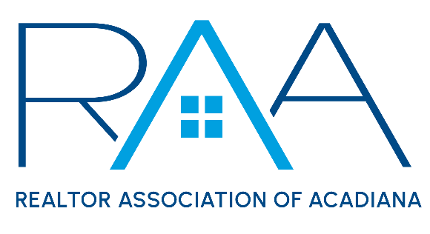
Board of Directors
April 29, 2025
9am/ RAA

MINUTES

I Call to Order: Ken Simeral, President called the meeting to order. He established a quorum had been met and note one absence: Paul Arceneaux

II Approval of Consent Agenda: A MOTION was made and seconded to approve the April Consent Agenda as presented. MOTION CARRIED

III Acceptance of Financial Items : A MOTION was made and seconded to accept the REALTOR® Association of Acadiana’s financials as of March. MOTION CARRIED

A MOTION was made and seconded to accept the RAA Properties financials as of March. MOTION CARRIED

Keisha Leblanc reviewed with the board the following:
- International Potluck Event Costs: Estimated cost for the event was under $2,000. All board members were pleased with the event and hoped it would become an annual event.
- REALTOR® Relief Fund/ RAA’s annual donation of $5,000: Leblanc stated RAA had received an email requesting a donation to the REALTOR® Relief Fund. The 2025 budget allocated $5,000 for this purpose. MOTION was made and seconded to authorize the CEO to make a $5,000 contribution on the Association’s behalf. MOTION CARRIED It was also discussed to possibly offer a QR Code for members to donate well at an upcoming event.
- HELOC: Leblanc discussed the possibilities of the RAA securing a HELOC loan on 234 Rue Beauregard. The board declined to move forward with the HELOC.
- 90 Day CD: Keisha Leblanc reported the current 90- Day CD of $500,000 would be up for renewal in early May. The board MOTIONED to authorize the CEO to renew the CD for an additional 90 days with our bankers at Hancock Whitney. MOTION CARRIED

IV Discussion Items:

- MLS: Christie House Theaux provided a ROAM Board of Manager update. The board discussed at length the Showingtime transition issues members were still experiencing. Staff will once again communicate with Showingtime to discuss these issues. It was announced that the Southwest Association of REALTORS® would be launching a Paragon MLS platform over the summer.

- Approval of the 2026 Nominating Committee: A MOTION was made and seconded to approve the following members to serve on the 2026 RAA Nominating Committee:
  - Erica Taylor, Chair
  - Jim Keaty, Keaty real Estate
  - Toni Effinger, RE/MAX Excellence
  - Candra Scott REAL Broker
  - Claire Disch, Dwight Andrus

MOTION CARRIED

- Approval of the Non-CE vendor contract: A MOTION was made and seconded to approve the proposed Non-CE Vendor Contract as presented with a few grammatical changes. MOTION CARRIED

- Report from the Professional Standards Committee:

A MOTION was made and seconded to enter into Executive Session to review a decision by the Professional Standards Committee. MOTION CARRIED

A MOTION was made and seconded to exit Executive Session MOTION CARRIED

A MOTION was made and seconded to accept the Professional Standards Hearing decision from March 14, 2025. MOTION CARRIED

- National Association of REALTORS®: No report/ update
- Louisiana REALTORS® : Simeral announced the dates for the upcoming Louisiana REALTOR® Legislative Conference in May in Baton Rouge.

V Strategic Thinking, Planning and Visioning: The board discussed NAR’s new changes to the CCP rules as it relates to Delayed Marketing status.

VI New/ Old Business:
- The CEO brought to the board’s attention a request from RAA member, Greg Reggie concerning the RAA membership Roster. This item will be added to the May board of Directors meeting.

VII Upcoming Events: Simeral reviewed with the board the upcoming events for the Association.
- Louisiana REALTORS® Conference in Baton Rouge May 5-7th REALTOR® Day is Tuesday, May 6th.
- RAA Membership Appreciation Event: Tentative date is Fall 2025
- YPN Morning Buzz: Thursday, May 15th 8:30am @ The Room at Corner Bar
- YPN Morning Buzz: Thursday, June 12th 8:30am @ The Room at Corner Bar
- Joint Industry Luncheon: Thursday, May 15th 11:30 @ Le Pavilion. Topic is a Mayoral Forum, local parish Mayor’s will share new development opportunities with members.

With no further business the meeting was adjourned.

