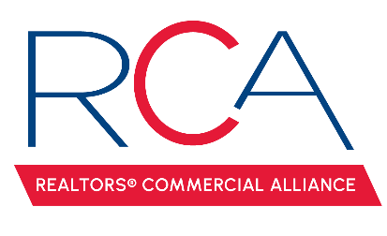

MINUTES

REALTORS® Commercial Alliance
Board Meeting
April 22, 2025

- Welcome & Introductions: Monty Warren, President, called the meeting to order.

- Approval of Minutes: A MOTION was made and seconded to approve minutes from the February 12, 2025 meeting. MOTION CARRIED

- Reviewed the account balance. It was noted that the current balance included some of the ACO income but it does not include the membership dues for 2025.

- Membership Update: 190 Active REALTOR members, 15 Associate members, and 36 Affiliate members.

- LACDB Update: Caitlyn Williams reported on the recent LACDB BOD meeting, where they discussed:
  - Moody’s Contract Renewal & Software Update. LACDB has not signed a contract with Resimplifi. The current contract expires with Moody’s on June 30, 2025. Once the contract has been executed, LACDB will schedule on site training with each CID.
  - TRENDS is coming up on May 1^{st,} and tickets are still available.

- RAA Update: Paul Arceneaux reported on the recent RAA BOD meeting, where they discussed:
  - AC Contract with Chapman’s. Chapman’s has already been on site to service the AC’s and has been great to work with!
  - Landscaping project was approved and will begin soon.
New Requests for RCA:
  - Commercial Listing Agreement. A MOTION was made to decline the request. MOTION CARRIED.
  - CREXI Requests an API Feed. A MOTION was made to decline the request. MOTION CARRIED.
  - Land Listings in the MLS. Amber informed the committee that if they are also MLS users that ROAM Rules require ALL land listings to be input in the MLS regardless of whether they are zoned commercial.

- CE Classes: Amber proposed a few education options. Paul Arceneaux will review the list of classes provided by CCIM to select a few options to present at our next meeting. It was discussed that Brent Lancaster will be offering a few commercial virtual classes, and the RCA Board is interested in offering some of those as well. LR will have the Commercial Mandatory Alternative approved this month with the LREC. Amber will schedule these classes as soon as they are available.

- LEDA Breakfast Series. Mark Mouton updated the board on our first event in the breakfast series. We had positive feedback all around. It was noted that our next event in the series will be August 27th. We are working to reschedule the October meeting with the Municipality Mayors. Mark is working on two survey projects that he needs RCA’s collaboration and input for Commercial Property Asset Survey Project and Permit Experience Survey. Board members will review Mark’s survey questions and report back with any feedback/suggestions. Amber will include the surveys in the next RCA Monthly Newsletter and Social Media Pages.

- ACO Update. The board reviewed the ticket and sponsorship sales, attendance, and survey feedback.

- Calendar of Events: A MOTION was made to have the June RCA Social at Corner Bar. MOTION CARRIED. Amber will schedule based on Corner Bar’s availability and email response from the board of directors. A MOTION was made to have the September RCA Social at LaFonda’s. MOTION CARRIED. Monty Warren will assist Amber with scheduling with LaFonda.

- Next Board Meeting: The next RCA Board Meeting will be July 23rd at 11:30 am.
With no other business to discuss, the meeting was adjourned.

