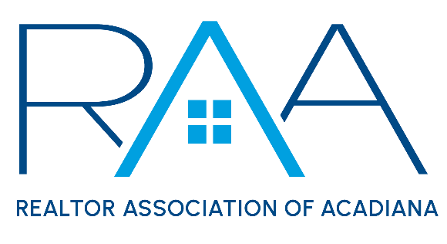
Board of Directors
March 25, 2025
9am/ RAA

MINUTES

I Call to Order: Ken Simeral, President called the meeting to order and noted there were no absences for the meeting.

II Approval of Consent Agenda A MOTION was made and seconded to approve the March Consent Agenda. MOTION CARRIED

III Acceptance of Financial Items A MOTION was made and seconded to accept the March financials for the REALTOR® Association of Acadiana and RAA Properties. MOTION CARRIED

A MOTION was made and seconded to begin charging $35 for Joint Industry Luncheon registrations starting in August of 2025. MOTION Carried

A MOTION was made and seconded to authorize the CEO to sign a landscaping contract with Gulf Coast Landscape for 234 Rue Beauregard. MOTION CARRIED

IV Discussion Items:

- MLS: Christie House Theaux provided a ROAM board of managers update. Simeral reported that the request from RAA to Lake Charles for Supra reciprocity was denied by the Lake Charles board. Staff provided an update on the Showingtime transition issues from the Appointment center to the APP only. Staff will continue to monitor all transition issues and will keep the board updated.

- DeYoung Lawsuit Update: Simeral reported RAA and the other defendants had submitted a request for dismissal of the lawsuit. Next step would be for the judge to review the pleading and render a decision. It will likely take a few months before a decision is made.

- Future Board meeting Dates and Times: Simeral reported the recent poll to change the meeting time for the monthly RAA board meetings to lunch indicated that mornings still worked best for everyone. Board meetings will remain at 9am on the 4th Tuesday of the month.

- National Association of REALTORS®: No report
5. Louisiana REALTORS® : Board members reviewed the agenda for the upcoming LR Legislative Conference May5-7th . A MOTION was made and seconded to reimburse all RAA Board Members and 2025 RAA leadership Class members the registration costs and a 1-night stay at the conference hotel. MOTON CARRIED

V Strategic Thinking, Planning and Visioning: The board spent 45 minutes discussing CCP.

VI New/ Old Business:
1. Member Appreciation Event Update: Staff provided an update for the Member Appreciation event.

2. Erica Taylor discussed she had been approached by a home inspector to request RAA reconsider changing its current policy on what member types can access Supra. A MOTION was made and seconded to request the MLS Committee add Supra Access by home inspectors to its April Agenda. MOTION CARRIED

VII Upcoming Events: Simeral reviewed the upcoming event for the RAA
- Louisiana REALTOR Legislative Outreach: Thursday, March 20th 11am @ Petroleum Club.
- Honor Society Brunch: Friday, March 28th 10am-Noon @ Fezzo’s Broussard
- Acadiana Commercial Outlook: Wednesday, April 9th 8:30-12:30pm @ LITE Center
- YPN Morning Buzz: Thursday, April 10th 8:30am @ The Room at Corner Bar
- Parade of Homes REALTOR® Day: Thursday April 10th
- International Potluck Event: Wednesday, April 23rd 11am-1pm Downtown Convention Center
- Louisiana REALTORS® Conference in Baton Rouge May 5-7th REALTOR® Day is Tuesday, May 6th.
- RAA Membership Appreciation Event: Tentative date is Fall 2025
- YPN Morning Buzz: Thursday, May 15th 8:30am @ The Room at Corner Bar
- YPN Morning Buzz: Thursday, June 12th 8:30am @ The Room at Corner Bar
- Joint Industry Luncheon: Thursday, May 15th 11:30 @ Le Pavilion. Topic is a Mayoral Forum, local parish Mayor’s will share new development opportunities with members.

With their being no further business the meeting was adjourned.

