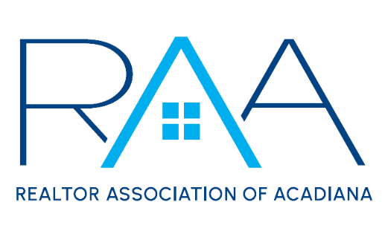
Events Committee Meeting
April 15, 2025
Minutes
- Call to Order: Sam Hayes and Elena Ladmirault, Event Chairs, called the meeting to order at 10:01 am.
- Member Appreciation
  - Budget: Chairs told the committee we got another sponsorship of $1,000 from Zillow/Showingtime so we now have a budget of $10,750.
  - Date: The date is scheduled for September 25th from 11am to 2 pm at Premier Lanes.
  - Food: Madison, RAA Staff, told the committee premier lanes has partnered with the Cajun Table for food. Once they send her over the menu options she will bring them to the committee.
  - Activities: The committee decided on no arcade or bumper cars. We will have lanes for bowling and laser tag. The committee also discussed not giving out drink tickets but still having a cash bar.
- Gumbo Cook-Off
  - Financials: Susan, RAA Staff, told the committee that last year we lost $1,700 at this event. The committee discussed ticket prices to make sure we try not to lose money this year. The committee decided on $15 tickets for the gumbo cook-off for everyone and kids 12 and under get in for free. She also brought up an incident that occurred with a member participating in the cook-off last year who broke the rules. A Motion was made and passed to suspend this member from participating in the 2025 Gumbo Cook-Off.
  - Layout: Elena, Co-chair, brought up the tents in the middle of the layout to see what the committee wants to put there. They discussed making these a sweets tent, drinks tent, and possibly potato salad tent. Home Bank agreed to provide the waters and cokes again this year.
  - Alcohol: Madison, RAA Staff, spoke about selling seltzers and beers during the event. Susan will investigate getting insurance for that day to see how much it would cost.
  - Theme: The Committee decided to vote on a theme at the next meeting.
- New Business: There was no new business
- With there being no further business, the meeting was adjourned at 10:52am.

