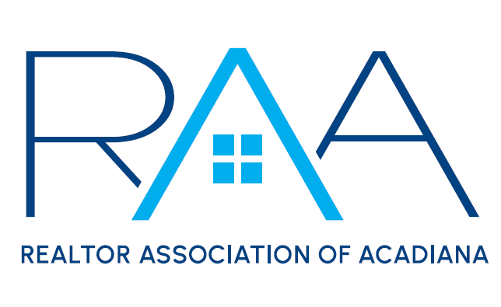
Cultural Diversity Committee
Chairs: Jeff Bower & Annette Porter
April 1, 2025
9:30 am

Agenda

- Call to Order – Jeff Bower & Annette Porter: Called the meeting to order at 9:30 am.
- International Potluck- Jeff and Annette asked the committee to spend the first 10 minutes reaching out to members to sign up for the potluck and get a personal invitation.
- Social Media Content: The committee discussed the months ahead and the designations to create a social media series on. Madison, RAA Staff, will post a miniseries 2-3 minutes long on RAA Insider and a larger series on our public facing accounts of longer videos. Each month the committee chose 2 designations and discussed who would be good for each of these topics. The committee will reach out to those members and ask if they are interested and comfortable filming these videos. They will be asked a series of questions during these videos. They will start with a quick explanation, the history, and their personal connection. They will then move on to three questions chosen from a list the committee came up with. The committee asked Madison, RAA Staff, to post on RAA Insider asking what heritages we have in our association so we can acknowledge all of our members.
- With there being no further business, the meeting was adjourned at 10:42am.

