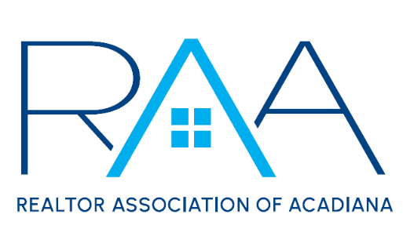
Events Committee Meeting
February 27, 2025

Minutes
- Call to Order: Sam Hayes and Elena Ladmirault, Event Chairs, called the meeting to order at 2:01pm.
- Introductions: Chairs introduced themselves as well as Madison Ray, Staff Liaison.
- Member Appreciation
  - Budget: Chairs discussed that the Board approved an event budget of $9,000. Then went on to say we have received $500 from Supra and $250 from Rapattoni in sponsorships. So as of now we have a total budget of $9,750.
  - Date: Committee went back and forth on a date and decided on looking to see if May 14th was available at the Bowling Alley.
  - Venue: Committee discussed that they liked the bowling alley and think it could be a great venue with a few tweaks. The committee took a vote between the bowling alley and Acadian Village. The bowling alley won with a vote of 16 to 13. We decided we would still investigate Acadian Village but focus our efforts on the bowling alley first. The committee decided on making this a 3-hour event instead of a 4-hour event and removing the bumper cars. We discussed looking into different menu options to see what they can offer besides pizza. The committee discussed what we could add with the money saved and decided to investigate drink tickets or RAA Swag.
- Gumbo Cook-Off
  - Band or DJ
    - Budget: $3,000
      - Elena, Co-Chair, told the committee she spoke with DJ Digital, and he would do the event from 5:00pm – 7:30pm for the budget of $3,000. The committee also brought up Scott Domingue for a band. After the committee discussed they decided to try out a DJ this year to see how the change works. A motion was made and seconded to hire DJ Digital for the Gumbo Cook-Off. Motion Carried. Elena, Co-Chair, will get in touch with Digital to secure this date.

- New Business: There was no new business
- With there being no further business, the meeting was adjourned at 2:47pm.

