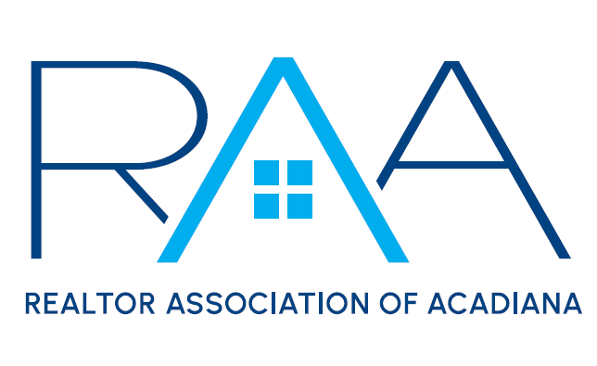
Cultural Diversity Committee
Chairs: Jeff Bower & Anette Porter
March 12, 2025
11:00 am

Agenda

- Call to Order – Jeff Bower & Annette Porter: Called the meeting to order at 11:03 am.
- Introductions: Ken Simeral, RAA President, Introduced the committee and the chairs.
- New Business
  - Cultural Diversity Social Media Content: Jeff Bower, Chair, told the committee that we are going to start a small video series to educate the membership about cultural diversity. These videos will be posted once a week on RAA Insider and be 1-2 minutes long. Jeff asked the committee to get involved with these videos and help with topics. There will be a few videos taken after each meeting so they can roll out weekly. Apart from the small series we will have a larger series of videos that will be posted on the RAA page monthly. These videos will be to educate our community and show how REALTORS® are diverse. These videos will be a few minutes long and the topic is going to align with the awareness of each month.
  - International Lunch: Jeff and Annette, Chairs, informed the committee on a new event. An International Potluck Lunch. This event will be on April 23rd at the Downtown Convention Center. From 11 am to 1 pm members will bring a dish to feed about 20 people. Each dish will represent their culture. This event will kick off festival international week. Annette is going to get with a musician for entertainment. Jeff, chair, asked the committee members to get there at 10 to set up. Each dish will have a name with what it is and if there are any dietary restrictions. Madison Ray, RAA Staff, will create a google spreadsheet where members can sign up and tell what they are bringing.
- With there being no further business, the meeting was adjourned at 11:38am.

