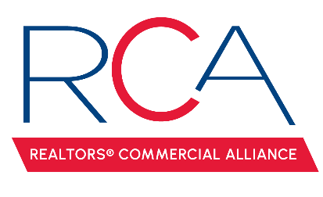

MINUTES

REALTORS® Commercial Alliance
Board Meeting
Wednesday, February 12, 2025

- Welcome & Introductions: Monty Warren, President called the meeting to order.

- Approval of Minutes: A MOTION was made and seconded to approve minutes from the December 4, 2024 meeting. MOTION CARRIED

- Clinton Shepard with CCIM spoke to the group about CCIM and their path forward. Clinton asked the RCA to be a sponsor for 2025. A MOTION was made and seconded to be a $5,000 Strategic Sponsor for CCIM in 2025. MOTION CARRIED.

- Reviewed the account balance. It was noted that the current balance included the revenue from LACDB.

- Membership Update: 203 Active REALTOR members, 17 Associate members, and 35 Affiliate members. RCA Membership is 69% renewed for this current billing cycle.

- LACDB Update: Caitlyn Williams reported on the recent LACDB BOD meeting where they discussed:
  - Moody’s Contract Renewal & Software Update. LACDB has created a work group to demo a new software option to replace Moody’s.
  - LACDB agreed to sponsor the ACO as a Break Sponsor for $1,500.
  - Bython requested an update on how RCA wanted to allow the CID discount for Associate members. It was agreed to monitor and revisit the amount of Associate members in Q3.

- RAA Update: Paul Arceneaux reported on recent RAA BOD meeting where they discussed:
  - AC Contract with Chapman’s to replace AC Sales.

- CE Classes: Amber proposed a few education options. The board would like to see what CCIM can offer if we pay directly for the classes.

- LEDA Breakfast Series. Mark Mouton has orchestrated three breakfast meetings. They will be Monique Blanco on March 27th, a LEDA Update estimated in August, and Municipality Mayors on October 15th.

- Calendar of Events: It was brought up that Amber is having issues getting The Chimes to call her back to schedule a social. A MOTION was made to have the next social at Superior Grill. MOTION CARRIED.

- ACO Update:
  - Speakers – the committee is meeting to finalize the keynote speaker
  - Ticket Sales – 20 tickets sold so far
  - Sponsorships – 4 sold so far
  - Special Invitations – the board would like to include Warren Abadie.

- Next Board Meeting: The next RCA Board Meeting will be April 17th at 11:30 am.
With no other business to discuss the meeting was adjourned.

