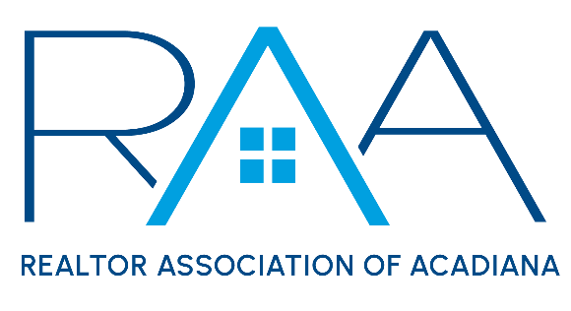
Board of Directors
January 28, 2025 9am/ RAA
MINUTES

I Call to Order: Ken Simeral, President called the meeting to order. He noted the following absences:
Christie House Theaux
Tyler Rush
Kim LaFleur

Board Members were asked to sign the 2025 Board of Directors Conflict and Confidentiality Statement.

John Whitney with Showingtime was then zoomed into the meeting to discuss RAA’s contract with Showingtime.

II Approval of Board Minutes: A MOTION was made and seconded to approve the minutes from the December 2024 board of directors meeting. MOTION CARRIED

III President’s Report:
- 2025 Dues and MLS Collection: Board members were presented with the chart of current REALTOR member and MLS subscriber renewals for 2025.

- MLS: Board members were provided with a ROAM Board of Managers update. It was discussed that the CEO requested a Supra reciprocity agreement with the Southwest Louisiana Association of REALTORS® (SWLAR). SWLAR has requested additional information. Susan Holliday will follow up with the CEO at SWLAR to provide any additional information needed.

The board then discussed the RAA Showingtime Contract. A MOTION was made and seconded to discontinue the Appointment Center contract on February 28th and move to the “app” only option via ROAM for March 1st. MOTION CARRIED

- DeYoung Lawsuit Update: The board was provided with an update on the current status of the DeYoung Lawsuit in which RAA is a named defendant.

- Louisiana REALTOR® Conference: Simeral reviewed with the board the details of the upcoming Louisiana REALTOR® Conference in Lake Charles.

- National Association of REALTORS®: Simeral announced RAA had successfully completed Core Standards for 2024. Susan Holliday, CEO was recertified as an RCE ( Real Estate Certified Executive). Board members were then provided with a litigation update on cases NAR is currently involved.

- RAA Operations: Simeral reported staff has completed the rebranding of RAA Talk to the RAA Insider. It was reported a new Code of Ethics cycle began January 1, 2025 and concludes December 31, 2027. In addition to the Code of Ethics all REALTOR® members would have to complete an additional 2 hours of Fair Housing training during this cycle period.

Simeral stated he had met with the Events Committee chairs and they were considering hosting a RAA member Appreciation Event which would be a combination of REALTOR® Appreciation and Affiliate Appreciation.

Finally, it was announced that Wendy Howell had resigned as the ACPAT chair for 2025.

IV Treasurer’s Report: Keisha LeBlanc, Treasurer reviewed with board the year end financials for 2024 with the RAA board. She noted as of December 31st RAA had $785,077 in its Prudential Investment account. She reviewed with the new board members the call sheet provided by RAA staff for new member assigned calls. Every month board members are asked to contact new REALTOR members to welcome them into the organization. Since the board meeting had already been in excess of two hours it was discussed that Leblanc would do a deeper dive on the 2024 Year-end financials at a subsequent board meeting.

A MOTION was made and seconded to accept the Treasurer’s report as presented. MOTION CARRIED

Paul Arceneaux had previously provided the board with an update on the RFP’s for a new AC Vendor. A MOTION was made and seconded to authorize the CEO to sign a new service agreement with Chatman’s AC. MOTION CARRIED

V Committee Reports:
a. MLS: Carol Grindrod: Chair presented the MLS Committee minutes from January of 2025. A MOTION was made and seconded to accept with MLS Committee minutes as presented with the exception Item #1 under new Business regarding the request from Clay Boudreaux. The Board requested the MLS Committee invite Clay Boudreaux to attend a future MLS meeting to thoroughly discuss his request regarding additional flood information inside of the MLS. MOTION CARRIED

VI CEO Report: No oral report was provided.

VII New/ Old Business:

VIII Upcoming Events: Simeral reviewed with the board of directors the upcoming events for the RAA and encouraged all board members to attend as many of these events as possible.
1. Louisiana REALTORS® Winter Conference: Feb.3-4th in Lake Charles
2. Legislative Committee: Wednesday, February 5th at 11am @ RAA
3. Honor Society Committee: Thursday, February 6th 1pm @ RAA
4. YPN Morning Buzz: February 13th 8:30am @ The Room at Corner Bar
5. Property Management: Tuesday Feb. 18th 11:30am @ RAA
6. Broussard Economic Development Lunch: Wednesday Feb. 19th @ The Ballroom in Broussard
7. RAA Annual Awards Luncheon: Thursday, February 20th @Le Pavillon

A MOTION was made and seconded to conclude the January Board Meeting. MOTION CARRIED

