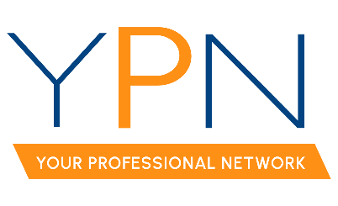
REALTOR® Association of Acadiana
234 Rue Beauregard
Lafayette, LA 70508
Tuesday, September 3, 2024

Present: Blake Weaver, Tyler Rush, Casey Oliver, Edward Campbell, Dyllan Hawkins, Maple Conston, and Rob Stewart
Late: Matt Long
Absent – Unexcused: Alyson Schexnayder and Erica Taylor
Present Non-Board Members: Jacob Romero and Susan Holliday
MINUTES
- Call to Order – Blake Weaver, President, called the meeting to order at 2:00pm.
- September 12th – Morning Buzz
  - Topic: Putting Safety First was confirmed.
  - Panelists: Matt Oliver with Advantage Training Academy and Sage Breaux with Delta Defense were confirmed.
  - Sponsor: Vernon Jenkins with Southwest Funding was confirmed.
  - After only receiving one safety-related story from the membership, it was decided to forgo the idea of sharing member stories and instead focus on hands-on approaches.
- October 10th – Morning Buzz
  - Topic: Behind the Deals: Tactics from Top Producing Agents was confirmed.
  - Panelists: Blake Arceneaux, Kate Mouton, Tyler Vallot, and Debbie Greene were confirmed.
  - Sponsor: Brad Aldridge with Apex Home Inspection was confirmed.
- November 14th – Food Drive
  - Time: 11am – 3pm was confirmed.
  - Location: The Room at Corner Bar was confirmed. Blake Weaver, President, will follow up with Chris at Corner Bar regarding the room rental and logistics.
  - Attendees will have to drop off 5 canned goods to gain entry to the event.
  - Sponsors:
    - Cooking: Brad Aldridge with Apex Home Inspection was confirmed.
    - Monetary: Attendees suggested Prime Title, American South Mortgage Lending, and Goosehead Insurance to sponsor the event as they are all interested in sponsoring a YPN event. Jacob Romero, RAA Staff, will contact each office to confirm interest. The cost to sponsor is $300.
  - DJ: Dyllan Hawkins, Director, will confirm the availability and cost of the DJ.
  - Prize: Annual MLS dues were confirmed.
  - Trailer and Tent: The Keaty trailer and tent were confirmed.
- Elections
  - The revised election timeline was presented. Attendees were reminded to reach out to eligible members to submit their nominations.
- December 12th – Morning Buzz
  - Topic: Naughty or Nice was confirmed.
  - Sponsors: Cross Country Mortgage and MD Title were suggested. Jacob Romero, RAA Staff, will reach out to both offices to confirm interest.
  - Panelists: Attendees suggested using the sponsors, Ory Comeaux with Cross Country Mortgage and Margo Dugas and Meghan Young with MD Title, as well as Christie Theaux, RAA President, to serve as panelists. Jacob Romero, RAA Staff, will reach out to all parties to confirm interest.
- YPN Event Outreach
  - Board members were reminded to continue to call new agents to come to YPN events with the updated YPN membership list.
With there being no further business, the meeting was adjourned at 2:42pm.

