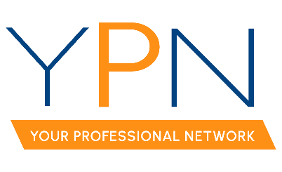
REALTOR® Association of Acadiana
234 Rue Beauregard
Lafayette, LA 70508
Wednesday, April 3, 2024

Present: Blake Weaver, Tyler Rush, Dyllan Hawkins, Casey Oliver, Matt Long, and Maple Conston
Late: Rob Stewart and Edward Campbell
Absent: Alyson Schexnayder (excused) and Erica Talyor (unexcused)
Present Non-Board Members: Susan Holliday and Jacob Romero
MINUTES
- Call to Order – Blake Weaver, President: Called the meeting to order at 2:02pm.
- April 11th – Acadiana REALTOR Summit
  - Details about the event were confirmed.
  - Agents with 0-3 years of experience will be able to pick up their free drink ticket at the YPN booth the day of the event.
- May 9th – Morning Buzz
  - Topic: How to Protect You and Your Clients was confirmed.
  - Sponsor: Maria Pitre with Sure Title (paid) was confirmed.
  - Panelist: Wesley Vanmieghem was confirmed.
- June 13th – CE Social
  - Attendees discussed aspects of the event. A decision was made to pursue the CE aspect of the event if the Legal Descriptions class is approved by LREC by the May Board meeting. If not, a 1-hour long Morning Buzz style of engagement will take place instead, followed by the social. This will be finalized at the next board meeting.
  - Attendees are responsible for reaching out to offices to request sponsorships.
- July 18th – Cornhole Tournament
  - Attendees discussed aspects of the event. 4 offices are confirmed as Gold Sponsors and 1 office as a Bronze Sponsor. The sponsorship form will go live early to mid-May.
  - Dyllan Hawkins, Board Member, confirmed Raelyn Payne and the DJ for the event.
- August 15th – Morning Buzz
  - Attendees discussed aspects of the event. Susan Holliday, RAA Staff, suggested the idea of an NAR settlement update with the proposed changes (e.g. no compensation in MLS) and what that means for the industry moving forward. Panelists would include Susan, the executive committee, the legal counsel, and the RAA’s attorney.
  - Charlotte Dunbar with Reliant Title will be the sponsor.
- Potential Future Morning Buzz Topics
  - Attendees discussed possible future morning buzz topics. Blake Weaver, President, suggested having a top agent panel for October. Attendees discussed having two local agents and two out of parish agents to provide different perspectives. Attendees are expected to reach out to agents to confirm interest and availability.
- YPN Event Outreach
  - Board members were reminded to continue to call new agents to come to YPN events with the new Q2 member list.
- New Business – There was no new business.
With there being no further business, the meeting was adjourned at 3:11pm.

