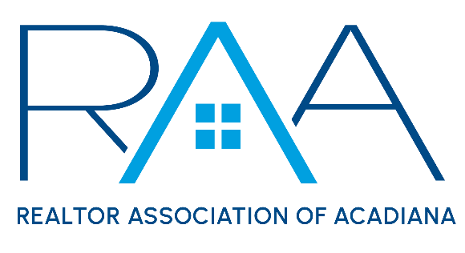
Board of Directors
September 24th 9am/ RAA

I Call to Order: Christie House Theaux, President called the meeting to order and noted the following Board Members were absent: Blake Weaver, Monty Warren and Wes Stonicher.

II Approval of Board Minutes: A MOTION was made and seconded to approve the minutes from the August Board of Directors Meeting. MOTION CARRIED

III President’s Report:
- ROAM Update: Theaux announced the ROAM go-live date would be Monday, September 30th. The board was briefed on possible issues with integration and how they would be addressed by staff. Theaux then provided an update on the September ROAM board of managers meeting.

Discussion then moved to the recent MLS Audit and feedback from the in-person Broker meetings RAA staff and Theaux had participated in.

A lengthy discussion ensued about the MLS Audit.

A MOTION was made and seconded to issue 1 ($100) MLS Audit fine per violation type per agent. Violation types include: (a) branded photos, (b) branded documents, (c) branded videos, (d) branded tours and (e) compensation. Any member wishing to appeal their fine must submit a written request to RAA staff within 14 days of the fine issuance. The RAA Board will set a date to hear all fine appeals within 30 days. MOTION CARRIED

- 2025 Elections: Theaux reviewed with the board the dates for the 2025 elections and the process by which the election will be held.

- Code of Ethics: Theaux reported 525 members still needed to take the NAR required Code of Ethics course before 12-31-24. Staff continue to email members who need to take the class.

- 2025 Billing: Theaux reviewed the 2025 billing for REALTOR® Membership dues and the new Annual ROAM Fees. It was noted annual dues would no longer have a 10% late fee on November 30th. The dues invoice is due on December 31st and if not paid would receive a $100 reinstatement fee. The ROAM MLS fees would also be billed on October 1st and would be due on December 31st 2024. All ROAM MLS invoices not paid by December 31st would receive a $50 late fee and MLS services would be suspended.

- 2024 Awards Committee: Theaux introduced proposed names for the 2024 Award Committee. A MOTION was made and seconded to approve the 2024 Award Committee members as presented. MOTION CARRIED

- Louisiana REALTORS®: Theaux reviewed the agenda for the upcoming Louisiana REALTORS® meeting. She encouraged everyone heading to the conference to attend the YPN Social. Finally, she discussed with the board the insurance coverage with Gallagher Insurance being offered to all local associations which should be reimbursed by Louisiana REALTORS®.

A MOTION was made and seconded to authorize the CEO, Susan Holliday to bind the coverage provided via the Gallagher quote ($15,699). MOTION CARRIED.

- National Association of REALTORS®: The board discussed the NAR CCP workgroup as well as the recent letter Alabama REALTORS® sent to NAR.

- Events update: Theaux encouraged all board members to attend this Thursday’s REALTOR® Appreciation Day at Premier Lanes. She also provided an update to the board on the Annual Gumbo Cook-off.

IV Treasurer’s Report: Keisha Leblanc, Treasurer, stated the current RAA membership was at 1751 REALTOR members. She reminded Board members to call all the new members. She reported on the Prudential investment balance as of August 31st and reviewed with the board members the current financials for the REALTOR® Association of Acadiana and RAA Properties, LLC.

A MOTION was made and seconded to accept the Treasurer’s report as presented.

V Committee Reports:
1. MLS: Kim LaFleur MLS Chair presented the September MLS Minutes. A MOTION was made and seconded to approve the MLS minutes with the exception of New Business #1 the nomination of Jalyn Plaisance to replace Nikki Wilson on the MLS Committee. MOTION CARRIED

The replacement of Nikki Wilson’s expired term on the MLS Committee will be sent back to the MLS Committee and be added to the October agenda for the committee to put forth a new member to replace Wilson.

2. YPN: Blake Weaver: Theaux reported for Weaver who was absent. She reviewed the YPN minutes from September. A MOTION was made and seconded to approve the YPN Minutes as presented. MOTION CARRIED

3. RCA: Monty Warren: Amber Miller reported for Warren on the recent RCA Minutes. A MOTION was made and seconded to Approve the RCA minutes as presented. MOTION CARRIED

VI CEO Report: Susan Holliday CEO announced that Payton Richard, Administrative Assistant was resigning her position to take a new position with the City of Rayne. She also announced that RAA Intern, Jacob Romero would graduate from UL in December and would be moving to Dallas to pursue his MBA. As a result, she will be hiring two new positions: Communications Coordinator and an Administrative Assistant. Job postings would be live ASAP.

She then announced that she would be circulating her CEO employee review to members of the Board and to the committee members where she has direct supervision over. Ken Simeral, RAA President Elect serves as the Chair of the CEO review and will collect the CEO performance reviews submitted and report back to the RAA board.

VII New/ Old Business: Susan Holliday, CEO supplied the RAA Board an update to the action items the board requested during the RAA Special Board meeting.

VIII Upcoming Events:
- REALTOR® Appreciation Day: Thursday, September 26th 11am-3pm at Premier Lanes
- YPN Morning Buzz: Thursday, October 10th at 8:30am at the Room @ Corner Bar. Top Producer Panel
- Broker Breakfast: October 18th 9am at the RAA Office
- Annual Gumbo Cook-off: Wednesday, October 23rd Parc International. 5-8pm. Music provided by Leon Chavis and Geno Delafosse.

With there being no further business, the meeting was adjourned.

