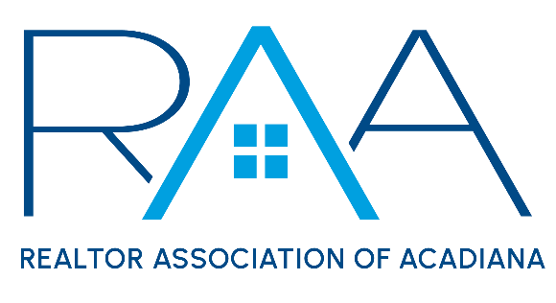
Board of Directors
October 22nd 9am/ RAA

I Call to Order: Christie House Theaux, President called the meeting to order and noted there were no board absences this month.

II Approval of Board Minutes: A MOTION was made and seconded to approve the minutes from the September Meeting. MOTION CARRIED

III President’s Report:
- MLS: Theaux provided the Board of Directors with an update from the recent ROAM Board of Managers meeting.

The board then began to review fine appeals from RAA members from the recent MLS Aduit.
      - Toni Effinger: A MOTION was made and seconded to approve the appeal. This Motion Failed. A MOTION was made and seconded to deny Ms. Effinger’s appeal. MOTION CARRIED
      - Michael Lamperez: A MOTION was made and seconded to deny Mr. Lamperez’s appeal. MOTION CARRIED
      - Rodolphe Toronto: A MOTION was made and seconded to deny Mr. Toronto’s appeal. MOTION CARRIED
      - Asim Baloch: A MOTION was made and seconded to deny Mr. Baloch’s appeal. MOTION CARRIED
      - Merrie Chris Leger: A MOTION was made and seconded to Approve Ms. Leger’s appeal. MOTION CARRIED
      - Carrie Monceaux: A MOTION was made and seconded to deny Ms. Monceaux’s appeal. MOTION CARRIED
      - Jamie Knight: A MOTION was made and seconded to deny Mr. Knight’s appeal. MOTION CARRIED
      - Rachel Thomas: A MOTION was made and seconded to deny Ms. Thomas’ appeal. MOTION CARRIED
      - Jay Smith: A MOTION was made and seconded to deny Mr. Smith s appeal. MOTION CARRIED
      - Abbie Young: A MOTION was made and seconded to deny Ms. Young’s appeal. MOTION CARRIED
      - Angi Trahan: A MOTION was made and seconded to deny Ms. Trahan’s appeal. MOTION CARRIED
      - Melanie Doyle: A MOTION was made and seconded to deny Ms. Doyle’s appeal. MOTION CARRIED

- 2025 Board Elections Update: Theaux reported the incoming President, Ken Simeral had selected Carol Grindrod to serve as the 2025 MLS Chair. Since Ms. Grindrod recently was elected as the Alternate in the 2025 election this left a vacancy in the Alternate Director position. Per the RAA By-Laws the seat then goes to the member who had the next highest number of votes which is Latonia Riggs with Evolve Realty.
- Louisiana REALTORS: Theaux reported Fort Polk local association requested a name change to West Central Louisiana REALTORS® which was denied by NAR due to a objection from the Central Louisiana Association of REALTORS®.
- National Association of REALTORS®: Theaux reported the NAR Delegate body would be voting to approve changes to Article 4 of the Code of Ethics. Theaux also reported the following: Katie Johnston was no longer NAR’s General Counsel, NAR will file a writ with the Supreme Court over DOJ Investigation and NFIP was extended until December 20, 2024.
- 2024 Awards: Theaux reported the 2024 Annual award nominations had been launched. She requested board members to submit applications for deserving members.
- Events Update: Theaux reported on the recent ACPAT Auction, REALTOR® Appreciation Day, and upcoming Gumbo Cook-off.

IV Treasurer’s Report: Keisha LeBlanc Treasurer, on the current membership numbers for the REALTOR® Association of Acadiana as well as the number of members who received an 2025 dues and MLS invoice. She requested board members refer to the new member board call list and encourage board members to make their calls as it does make a difference. She reported the balance for RAA investments at Prudential as of September 31st is $784,344.61. She then provided a report on the current financials for the REALTOR® Association of Acadiana and for RAA Properties and entertained questions from board members. Finally she requested the board approve computer upgrades for approximately $7,000 . A MOTION was made and seconded to Accept the Treasurer’s report as presented. A MOTION was made and Seconded to Approve the presented Computer upgrades for the 2024 budget. MOTION CARRIED

V Committee Reports:
1. MLS: Kim LaFleur, Chair reported on the minutes from the October MLS Committee Meeting. A MOTION was made and seconded to approve the minutes as presented. MOTION CARRIED
2. YPN: Blake Weaver. Chair reported in the October YPN Board Meeting. A MOTION was made and seconded to approve the YPN minutes as presented. MOTION CARRIED
3. RCA: Monty Warren: reported the section had not met since the last board meeting but they were gearing up for 2025 and would doing an installation banquet honoring Warren on Wednesday, December 4th

VI CEO Report:
- CEO Annual review: Holliday reported she had sent the Annual CEO Evaluation form and requested board members complete the form and return it to Ken Simeral.
- Staff: Holliday announced she had hired Lillian Rodrigue for the Administrative Assistant position with a November 4th start date.

VII New/ Old Business:
- EXP v Berkshire Hathaway: It was reported Berkshire Hathaway had paid the Arbitration Award to EXP and that the file was closed with the RAA.
- Lawsuit: Kiwi Bautista v Sean Hettich and Steven Desormeaux: A MOTION was made and seconded to enter into Executive Session. MOTION Carried.

A MOTION was made and seconded to exit Executive Session. MOTION Carried

VIII Upcoming Events: Theaux reported on the upcoming RAA event and requested board members make every effort to attend.
- Annual Gumbo Cook-off: Wednesday, October 23rd Parc International. 5-8 pm. Music provided by Leon Chavis and Geno Delafosse. Louisiana Heritage theme.
- YPN FOOD DRIVE: Thursday, November 14th @ the Room @ Corner Bar.
- YPN Morning Buzz: Thursday, December 12th The Naughty or Nice Edition 8:30am @ The Room @ Corner Bar

With there being no further business the meeting was adjourned.

