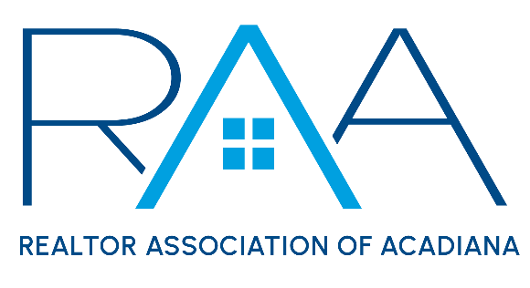
Board of Directors
May 21st , 2024 9am/ RAA

MINUTES:

I Call to Order: Christie House Theaux, President called the meeting to order and noted the following absences: Wes Stonicher and Blake Weaver.

II Approval of Board Minutes: A MOTION was made and seconded to approve the minutes as presented at the April board meeting. MOTION CARRIED

III President’s Report:
- National Association of REALTORS®: Theaux provided the board with a recap on the recent NAR Legislative Meetings.
- Board Retreat: June 7-9th in Grand Isle, Louisiana: Theaux updated the board on the logistics of the upcoming board of director’s retreat.
- Annual Meeting/ Broker Summit: Theaux prosed to the board a RAA Summit for Brokers and agents combined with an annual meeting during the lunch portion of the day. The proposed event would be held on Tuesday, June 25th @ The Madison in Broussard. The estimates cost would be $2900 for the rental of the facility plus food costs.

A MOTION was made and seconded to approve RAA hosting the Summit and the expenses associated with the event. MOTION CARRIED

Theaux then discussed with the RAA board of directors proposed changes to the RAA by-laws which included:
- Removal of Section XVIII : The MLS as it conflicts with the NAR Settlement.
- Removal of the Alternate Director
- Addition of a new seat for the ROAM Board of Managers

The board discussed these proposed changes and a MOTION was made and seconded to approve these changes to the RAA By-Laws and set the Annual Meeting for Tuesday, June 24th during the lunch portion of the Summit. MOTION CARRIED

- 2025 Elections: Theaux reported Ken Simeral, RAA President-Elect will launch the 2025 Nominating Committee for the upcoming election cycle. He would like the following members to serve on the committee: Reid Smith, Stefanie Kellner, Jacquelyn Cain Gleason and Ivan Jennings.

A MOTION was made and seconded to approve those members to serve with Ken for the 2025 Nominating Committee. MOTION CARRIED

- Louisiana REALTORS Update: Theaux reported the LR CEO, Norman Morris has informed her that Louisiana REALTORS was working to add language to an existing bill which would require all licenses to use a Buyer representative Agreement when working with a buyer. The bill was making it way through the legislative process. Additionally, the new Louisiana REALTOR® healthcare membership benefit would be launched this month and all members were invited to participate in a webinar with the carrier on May 29th .

- National Association of REALTORS® : Theaux reported the RAA CEO, Susan Holliday had submitted on behalf of RAA the required Appendix B to be included in the NAR Settlement. She also reported Eloise Gauthier would serve as the NAR Region 10 RVP for 2025.

- ROAM MLS Update: Theaux provided board members with the update on Key reciprocity for ROAM partners.

- MLS Semi Annual Billing: Theaux reported the semi-annual MLS bills would be sent out on Friday, may 31st and were due June 30th. Any unpaid bills on July 1st would receive a $50 late fee and have their serve cut off.

- Code of Ethics: Theaux reported RAA currently has 720 members still need to take the required Code of Ethics class before 12-31-24. Staff is sending notices to everyone on this list once a month and the Education Committee has the class scheduled live for members each month until December.

IV Treasurer’s Report: Keisha LeBlanc reviewed with the board the Treasurer’s report. She noted 2024 membership numbers were meeting budgeted expectations, which was good. She asked board members to make calls to new agents and reported the RAA investment account at prudential was at $746,917.04 as of April 30, 2024.

She then reviewed the current financials for the REALTOR® Association of Acadiana and RAA properties. She noted the recently approved RAA Summit expenses would be placed in the unbudgeted line item. She then entertained any questions from board members on the financials.

She then reported on RAA Properties: She noted both Dream Home Realty and Louisiana Abstract and Title (formerly Dream Home Title) has both signed new 2 year leases.

A MOTION was made and seconded to accept the Treasurer’s report as presented. MOTION CARRIED

V Committee Reports:
a. MLS: Kim LaFleur: Reported on the May MLS Committee Minutes. A MOTION was made and seconded to approve the MLS minutes as presented. MOTION CARRIED

b. YPN: Blake Weaver: Theaux reported for Weaver on the May YPN Minutes. A MOTION was made and seconded to approve the YPN minutes as presented. MOTION CARRIED

c. RCA: Monty Warren: Monty Warren reported on the RCA minutes and recent social at the Yard Goat. MOTION was made and seconded to approve the RCA minutes as presented. MOTION CARRIED

VI CEO Report: No report from the CEO.

VII New/ Old Business: Kim LaFleur reported that during the upcoming board retreat we needed to look at the staff roles and responsibilities and adding additional staff.

VIII Upcoming Events:
- Events Committee Meeting: Wednesday, May 22nd - 2pm @the RAA Office
- Be the best YOU with Tara Bienvenu: Thursday, May 23rd 9-noon @ RAA Office
- RAA Office Closed Monday May 27th for Memorial Day
- Push the Marketing Pedal with BBR Creative: Tuesday, June 4th from 9-11am. Session to focus on Emal Marketing.
- Joint Industry Luncheon: Wednesday, June 4th 11:30am at LePavillon. Guest Speaker is Scott Hughes, CEO for the Northwest Association of REALTORS®. Topic is to discuss the political climate and thoughts on the upcoming Presidential Election.
- Board Retreat: June 7-9th in Grand Isle, Louisiana
- YPN CE Social: Thursday June 13th. CE from 2-4pm on Legal Descriptions at The Room at Coner Bar. Social from 4-6pm at next door at Corner Bar
- YPN Cornhole Tournament: Thursday, July 18th at the Madison

With there being no further business the meeting was adjourned.

