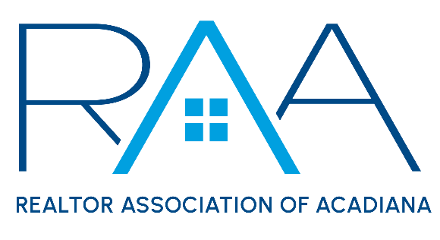
Board of Directors
March 26, 2024
9am/ RAA Boardroom

MINUTES

I Call to Order: Christie House Theaux, President called the meeting to order acknowledged a quorum had been met

She noted on board member absent: Blake Weaver

She then introduced RAA Member, Mohamed Bahlawan who requested the Board of Directors overturn a MLS fine he received during the February MLS Committee Meeting. A MOTION was made and seconded to deny Mr. Bahlawan’s fine appeal. MOTION CARRIED

II Approval of Board Minutes: A MOTION was made and seconded to approve the minutes from the February Board of Directors Meeting. MOTION CARRIED

III President’s Report:
- Peiffer Lawsuit Update: House updated board members on the Peiffer Lawsuit. She noted that RAA was listed as a co-conspirator to the suit. She then discussed next steps for the RAA in this lawsuit and how the recent NAR proposed settlement would effect RAA.

Risk Management items recommended by RAA’s General Counsel were discussed. A MOTION was made and seconded for the RAA Board to adopt a no cell phones allowed during the board meeting policy for all future board meetings. MOTION CARRIED

- National Association of REALTORS®: House reviewed with the board members the proposed Settlement with NAR and the status of RAA. It was discussed that parts of the current RAA By-Laws are in direct conflict with the NAR settlement. Specifically, Article VXIII MLS section 2 & 3. These 2 sections specifically mention and require cooperative compensation by MLS participants. Under the NAR proposed settlement this would not be allowed. It was discussed that RAA’s General Counsel is reviewing the By-Laws to see if these sections can simply be removed from the Bylaws or if an Annual meeting will be required to be called.

A MOTION was made and seconded that the board recommends removing section 2 & 3 of Article XVIII of the current RAA by-Laws with approval and review from RAA’s General Counsel. MOTION CARRIED

A MOTION was made and seconded to request that the MLS Committee review the RAA’s current policy on key reciprocity and encourage new policies which would expand reciprocity to other boards within the ROAM MLS system. MOTION CARRIED

A Motion was made and seconded to reconvene a Forms Task Force to review any RAA’s forms which may be affected under the proposed NAR Settlement. MOTION CARRIED

- Affiliate Appreciation Projected Costs v Budget: RAA CEO reported plans were set for the 2024 Affiliate appreciation event on Thursday, May 2nd at The Ballroom in Broussard. However, more broker sponsorships were needed to help underwrite the costs. Holliday will work to send personal emails to brokers seeking their support.

d. Louisiana REALTOR® Spring into Action Conference: House reported the LR Spring into Action Conference would be held in Baton Rouge on Monday, April 8th- Wednesday, April 10th . The schedule was reviewed by the board members. The RAA resolution for a state mandated use of a Buyer Representation form was discussed. Board members were encouraged to speak out in favor of the resolution at the upcoming meeting.

IV Treasurer’s Report: Keisha Leblanc, Treasurer reviewed with board members the current membership numbers as well as monthly board calls to new members. She reported the RAA investment account with prudential was at $747,532.25 as of February 29th. LeBlanc then reviewed the current financials for the REALTOR® Association of Acadiana and RAA Properties, LLC. She discussed a recent communication from the Association’s IT Vendor which was an increase in the monthly charge for security and would most likely put this line item over budget. She then reported on the current status of lease renewals for RAA Properties, LLC.

V Committee Reports:
a. MLS: Kim LaFleur: reviewed the minutes from the March MLS Committee. A MOTION was made and seconded to accept the MLS Committee minutes as presented. MOTION CARRIED
b. YPN: Blake Weaver: Susan Holliday reported for Blake Waver on the YPN happenings. A MOTION was made and seconded to accept the YPN Report as presented. MOTION CARRIED
c. RCA: Monty Warren presented the RCA report. A MOTION was made and seconded to accept the RCA report as presented. MOTION CARRIED
d. Events Committee: Holliday reported on the minutes from the recent Events Committee Meeting. A MOTION was made and seconded to adopt new pricing for the 2024 Gumbo Cook-off: Adults: $15, Children $5, Day of event set-up $10, Advanced $10. MOTION CARRIED
e. Professional Development: Holliday reported on the minutes from the Professional Development Committee Meeting. A MOTION was made and seconded to accept the minutes as presented. MOTION CARRIED

VI CEO Report: Susan Holliday, CEO, thanked the board for allowing her to attend the NAR AEI conference. She reported the conference was extremely valuable and provided good content to help further her professional knowledge. She also reported on the high number of members who still needed to take the Code of Ethics training requirements before December 31st, 2024 and discussed plans with the board on staff efforts in communicating with members who still needed the class.

VII New/ Old Business:

VIII Upcoming Events: House reviewed with Board members the upcoming RAA events.
- March Broker Breakfast: Friday, March 22nd @ 9am.
- RAA Office Closed for Good Friday: March 29th
- Louisiana REALTORS® Spring into Action Conference: April 8-10th in Baton Rouge. REALTOR day is Tuesday, April 9th .
- Honor Society Lunch: Friday, April 12th from 10am-noon at Fezzo’s in Broussard
- YPN Morning Buzz: Partnership with the Acadiana REALTOR® Summit Thursday, April 11th 8-5pm, social at the Yard Goat afterwards.
- Parade of Homes: REALTOR® Day is Wednesday, April 17th from 11-3pm
- ACPAT Annual Auction: Thursday, April 18th @ The Madison in Broussard from 5:30-8:00pm
- Louisiana REALTORS® Legislative Outreach: Friday, April 19th location is Petroleum Club from 10:30-1:30. Cost is $25
- Acadiana Commercial Outlook: Thursday, April 25th at the Lite Center

