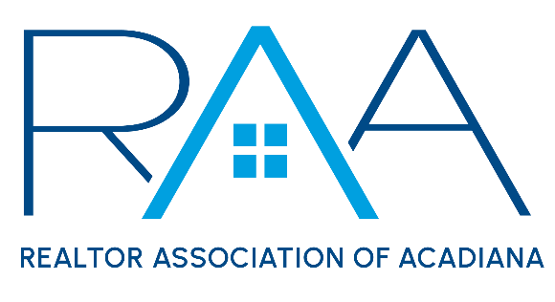
Board of Directors
June 8th @ 9am in Grand Isle

Present: Christie Theaux, Ken Simeral, Keisha LeBlanc, Erica Taylor, Charles Ditch, Kim LaFleur, Suzanne D’Ambrosio, Joy Cobert, Nick Hundley, Tyler Albrecht, Reid Smith, Susan Holliday

MINUTES:

I Call to Order: Christie Theaux, President and recognized a quorum had been met.

II President’s Report:
- Approval of MLS Administrative Hearing: A MOTION was made and seconded to go into Executive Session to review a report from an MLS Administrative Hearing. MOTION CARRIED

A MOTION was made and seconded to exit Executive Session: MOTION CARRIED

A MOTION was made and seconded to accept the MLS Administrative Hearing as presented. MOTION CARRIED

- MLS/ ROAM Update:
  - Approval of Listing Agreement: The board reviewed the work product from the Forms Task Force regarding the listing agreement and proposed changes to comply with the NAR Settlement. The board made considerable changes which will be sent back to the forms committee. The goal is to have the final document for the RAA Summit on Tuesday, June 25th .

House discussed, the proposed LR Forms library which will be made available to all LR members. These forms should be ready before the August 17th Settlement implementation date.

  - Coming Soon Status approved by ROAM Op’s: House reported ROAM Op’s committee recently approved the Coming Soon status and rules. Next step is to get the approval by the ROAM Board of Managers.
  - Concession’s Field: She updated the board that ROAM was recommending the removal of the concession field.
  - Removal of Compensation Field: A MOTION was made and seconded to authorize the staff to contact FLEX MLS to set the date of Monday July 15th to remove the Compensation field from the MLS. MOTION CARRIED

A MOTION was made and seconded to have the RAA staff perform an MLS Audit prior to entering ROAM and to ensure data compliance MOTION CARRIED

A MOTION was made and seconded to pay $25 per hour with a max spend of $7K to hire staff to assist with the audit. MOTION CARRIED

The Audit schedule is as proposed:

RAA staff to start promoting the Audit and Audit sheet starting on June 17th

All attendees of the RAA Summit will be given the Audit check list and requirements.

All brokers will be required to sign an acknowledgement form regarding the Audit and asked to audit their own listings during the week of July 15th.

The RAA Staff will start the audit of MLS data July 22nd. Any listing which was flagged in the MLS audit would receive a fine. The following fine structure was approved by the BOARD at this meeting.

$100 for any listing which still had compensation information included

$100 per occurrence for any listing still having branded material. For example, if a listing has a branded tour and a branded wire fraud document that listing agent would receive a $200 fine.

III New/ Old Business:

IV Upcoming Events: Theaux reviewed with the members the upcoming RAA events.
- YPN CE Social: 2-4pm CE on Legal Descriptions. Social at Corner Bar 4-6pm
- Property Management: Tuesday, June 18th 11:30-1pm @ the RAA Office
- REALTOR® Pride Event: Thursday, June 20th 5-7pm at Bolt Downtown
- RAA Broker & Agent SUMMIT: 8:30-4:30 at the Madison in Broussard
- RAA Office Closed on Thursday July 4th for America’s Birthday
- Be the Best You with Tara Bienvenu: Tuesday, July 9th 9am til noon @ the RAA office
- YPN Cornhole Tournament: Thursday, July 18th from 10am-5pm at the Madison in Broussard
- RCA Social: Thursday, August 22nd at LaFonda 4-6pm

With no further business the Meeting was adjourned.

