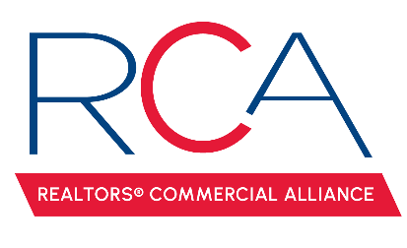

MINUTES

REALTORS® Commercial Alliance
Board Meeting
Thursday, April 11, 2024

- Welcome & Introductions: Caitlyn Williams, President called the meeting to order.

- Approval of Minutes: A MOTION was made and seconded to approve minutes from the January 18, 2024 meeting. MOTION CARRIED

- Reviewed the account balance. It was noted that the current balance did not include the 2024 membership dues or any funds from ACO.

- Billing Cycle update: 231 members billed at $35 and 197 renewed. 43 affiliate members were billed at $50 and 43 were renewed.

- LACDB Update: Todd Trahan reported on the recent LACDB BOD meeting where they elected to remove the compensation field from the system. It was suggested that all members review their listings and follow the checklist provided by LACDB on the final migration to Pro. Moody’s will teach a live class on Monday, April 22nd in Lafayette at 10 am and 1 pm, with lunch provided in between. Lunch will be paid for by Moody’s.

- RAA Update: A MOTION was made to discontinue the 25% contribution to commercial designations effective 12/31/2024. MOTION CARRIED.

- RAA Properties: Down Syndrome elected to not renew their lease and Dream Home Title has decided to take over that space and the conference room. Dream Home Realty is renewing its lease for 2 years.

- CCIM Sponsorship: A MOTION was made to do the $5,000 education sponsorship with the requirement that we can select the classes and provide 12 commercial-specific hours. MOTION CARRIED.

- Acadiana Commercial Outlook: Amber & Caitlyn updated the BOD regarding the speakers, food, sponsors, ticket sales, etc.

- Calendar of Events for 2024: the BOD selected May 9th from 4-6PM at the Yard Goat.

- Next Board Meeting: The next RCA Board Meeting will be on May 13th at 11:30 a.m.

- Proposal from Mark D. Mouton: MOTION to reinstate the breakfast series. MOTION CARRIED.

- RCA Roll Up Banner: MOTION to purchase the roll up banner. MOTION CARRIED.

With no other business to discuss the meeting was adjourned.

