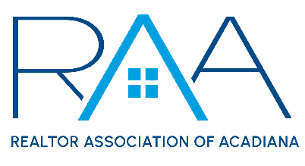

REALTOR® Association of Acadiana

234 Rue Beauregard

Lafayette, LA 70508

**Wednesday, March 20, 2024**

**Events Committee**

MINUTES:

1. **Gumbo Cook-Off 2024**: Chairs, Ethan Broussard and Duck Jenkins discussed with committee members in attendance various bands options and potential themes for the 2024 event which will be held on Wednesday, October 23rd at Parc International.

All members presents were allowed to vote on the band and the theme for the 2024 Event.

Geno Delofosse and Leon Chavis will be the band for the event and the Theme will be Louisiana Folklore. Cost for admission for the 2024 event will be $15 which is a $5 increase from the 2023 event.

Additionally, the committee is recommending a new policy to ensure that members who “hang out” during the day at the event also be required to pay an admittance fee. Staff will promote a Daytime party for members and bring in a DJ for a festive feel from 10am until the event officially opens to the public.

1. **REALTOR Appreciation Day 2024:** Again, several ideas were discussed with no clear path forward. The matter is once again referred to the RAA Board of Directors.

**III Affiliate Appreciation 2024:** The chairs reviewed the details of the upcoming Affiliate Appreciation event which will be held on Thursday, May 2nd from 11am – 1:30pm @ The Ballroom of Broussard. Theme is Red Carpet Affiliate Affair. There is still a need for Broker Sponsorships and staff will discuss these sponsorships with the Brokers at an upcoming broker meeting**.**

**With there being no further items for discussion the meeting was adjourned.**