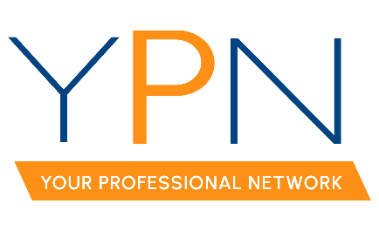

YPN Board of Directors
Wednesday, June 7, 2023

Present: Keisha LeBlanc, Lori McCarthy, Ashley Dauterive, Tyler Rush, Anttalisa Byers, Dyllan Hawkins, Alyson Schexnayder, Rob Stewart, Casey Oliver
Absent: Blake Weaver

MINUTES

- Call to Order: Keisha LeBlanc, President: Called the meeting to order at 2:00 p.m.

- Roll Call – Sign-in, Establish a Quorum: Keisha established a quorum had been met.

- June 8th – CE Social: Attendees discussed the upcoming CE Social. Keisha LeBlanc, YPN President, reported that she had spoken with Chris at Corner Bar to finalize the room setup. Ashley Dauterive, YPN Board Member, reported that she had communicated with both Maison Title and Home Bank regarding the setup of promotional items at the event.

- July 20th – Cornhole Tournament: Attendees discussed the details of the cornhole tournament and reviewed the sponsor package.

  - T-Shirts: The YPN Advisory Board has asked Allyson Abadie, YPN Staff Liaison, to order T-shirts for the YPN Board Members to wear at the event. Lori McCarthy, YPN Mentor, will reach out to her vendor contact for pricing.

- August 10th – Morning Buzz
  - Topic: Attendees discussed possible topics for the August Morning Buzz and decided on negotiating in real estate.
  - Panelists: Keisha LeBlanc, YPN President, will reach out to Kim LaFleur to hold a panel on negotiating along with another agent of her choosing.
  - Sponsor: Keisha LeBlanc, YPN President, will reach out to Brandon Bradley to sponsor.

- September 7th – Safety Workshop with Kelly Simpson
  - NAR Safety Grant Update: Keisha LeBlanc, YPN President, announced that they were not selected as a recipient of NAR’s Safety Grant. Keisha then reported that the event will go on as planned.
  - Continuing Education Credit: Allyson Abadie, YPN Staff Liaison, reported that the class was still pending approval from LREC.

- October 12th – Morning Buzz
  - Topic: Attendees discussed possible topics for the October Morning Buzz and decided to reach out to Alissa Jenkins and Katy Caldwell, hosts of the Realtor® focused podcast, “Hustle Humbly.”
  - Panelists: Lori McCarthy, will reach out to the producers of the podcast, “Hustle Humbly.”
  - Sponsor: Keisha LeBlanc, YPN President, will reach out to Jaime Trahan with Edge Mortgage to sponsor.

With there being no further business the meeting was adjourned at 2:48pm.

