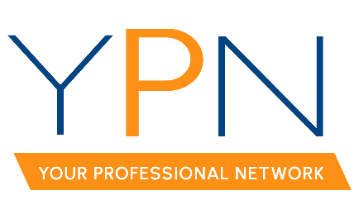

YPN Board of Directors
Wednesday, April 5, 2023

Present: Keisha LeBlanc, Blake Weaver, Lori McCarthy, Tyler Rush, Anttalisa Byers, Alyson Schexnayder, Rob Stewart, Casey Oliver
Absent: Ashley Dauterive, Dyllan Hawkins

MINUTES

- Call to Order: Keisha LeBlanc, President: Called the meeting to order at 2:01 p.m.

- Roll Call – Sign-in, Establish a Quorum: Keisha established a quorum had been met.

- YPN Event Outreach: Attendees requested that the YPN Staff Liaison, Allyson Abadie, provide the YPN Advisory Board with the list of new members from from January to April to personally invite each new member to the April Morning Buzz.

- NAR Safety Grant Update: Keisha LeBlanc, YPN President, provided an update regarding the NAR Safety Grant and announced that the funds would go towards hiring Kelly Simpson, a national speaker, to facilitate a 3-hour Safety Workshop. Keisha reported that this event will take place on Thursday, September 7.

A MOTION was made and seconded to attempt to submit the Safety Workshop for continuing education credit with the LREC. MOTION CARRIED

A MOTION was made and seconded for YPN to contribute $500 from the YPN budget for the Safety Workshop. MOTION CARRIED

- April 13th – Morning Buzz: Attendees discussed the details of the April Morning Buzz on Fair Housing. Keisha LeBlanc, YPN President, requested that all YPN Advisory Board members submit at least one Fair Housing question for the interactive quiz that will be played at the event. The panelists for the April Morning Buzz include Latonia Riggs, Matt Long, and Joy Cobert.

- May 11th – Morning Buzz:
  - Topic: The topic for May will be flood.
  - Guest Speaker: Keisha LeBlance, YPN President, confirmed that the Lafayette Floodplain Administrator, Clay Boudreaux, will be the guest speaker.
  - Sponsor: Keisha LeBlanc, YPN President, confirmed Toby Thimmesch as the sponsor.

- June 8th – CE Social
  - Keisha LeBlanc, YPN President, reported that the 3-hour Code of Ethics class has been submitted and is pending approval.
  - Keisha LeBlanc, YPN President confirmed that Maison Title will sponsor the event and will choose a partnering sponsor.

- YPN Fundraiser: Attendees discussed possible fundraising ideas and decided to host a Cornhole Tournament on Thursday, July 20. Blake Weaver, YPN President Elect, will reach out to Jesse Regan, owner of The Madison in Broussard, to see if YPN could use this venue for the tournament. Further details regarding the fundraiser will be discussed at the next meeting.

With there being no further business the meeting was adjourned at 3:04pm.

