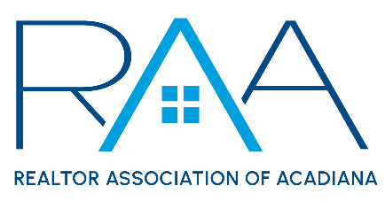

Events Committee Meeting
Thursday, April 19, 2023

MINUTES

Call to Order: Charlotte Dunbar & Ryan Petticrew (co-chairs) – Called the meeting to order at 9:03 a.m.

Charity Presentations: Attendees listened to presentations given by the top 10 charities selected at the previous meeting including: Acadiana Veteran Alliance, Foster the Love, CASA of St. Landry-Evangeline, Inc., Healing House, Acadiana Animal Aid, Gifting Grace Project, Inc., New Hope Community Development of Acadiana, The Hub, FUNraisers for St. Jude, and Ashmay's Seeds of Abraham.

Voting: All of the members who attended this meeting were able to cast their vote via secret ballot. Votes were given to Payton Broussard, an RAA Staff member, to be counted.

Affiliate Appreciation: Allyson Abadie, Events Committee Staff Liaison, reported that the Truss Room did not fit our needs for a venue and that the RAA Staff is planning a walkthrough at The Ruins. Ryan Petticrew, Events Committee Co-Chair, requested that all attendees sign up if they are interested in further planning for Affiliate Appreciation.

Upcoming Events: Ryan Petticrew and Charlotte Dunbar, co-chairs, announced that REALTOR® Appreciation will be held on Thursday, September 14, and that the Gumbo Cook-Off will take place on Wednesday, October 25.

Voting Results: Charlotte Dunbar, co-chair, announced the results of the votes. The following organizations were selected as RAA’s Charity Partners for the 2023 – 2025 Donation Cycle: Acadiana Veterans Alliance, FUNraisers for St. Jude, and CASA of St. Landry-Evangeline.
A MOTION was made and seconded to hold a supply drive at the Affiliate Appreciation event for Ashmay’s Seeds of Abraham who ranked fourth in the charity selection process. MOTION CARRIED

With there being no further business the meeting was adjourned at 10:45 a.m.

