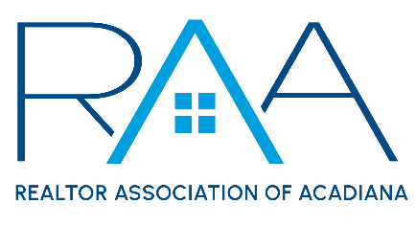

Events Committee Meeting
Thursday, March 23, 2023

MINUTES

- Call to Order: Charlotte Dunbar & Ryan Petticrew (co-chairs) – Called the meeting to order at 9:03 a.m.

- Charity Selection: Ryan Petticrew, co-chair, reported that 26 charity organizations were nominated for consideration in the RAA’s 2023 Charity Donation Cycle. Ryan then explained that the meeting attendees would review all submissions before casting a vote for their top 5 charities and that the top 10 organizations will be asked to present at the next Events Committee meeting.
  - Review List of Nominated Charities: Attendees reviewed each of the 26 charity organizations submitted including a brief description of the organization, information on how the money would be used, the organization's service area, and the year the organization was established.
  - Voting: Events Committee members voted for their top 5 charities via secret ballot. Votes were given to, Payton Broussard, an RAA Staff member to be counted.

- 2023 Events: Charlotte Dunbar, co-chair, reviewed the confirmed event dates for 2023.
  - REALTOR® Appreciation Day: Charlotte Dunbar, co-chair, reminded attendees that REALTOR® Appreciation Day will be held on Thursday, September 14 at the Cajundome Convention Center.
  - Gumbo Cook-Off: Charlotte Dunbar, co-chair, reminded attendees that the Gumbo Cook-Off will take place on Wednesday, October 25 inside Parc International.
  - Affiliate Appreciation: Attendees discussed ways to revamp Affiliate Appreciation in order to increase attendance and celebrate our affiliate members and have asked the RAA Staff to find a suitable venue to have a luncheon from 11 a.m. – 2 p.m. on Thursday, August 17. Ryan Petticrew, co-chair, asked that attendees interested in planning further details of this event to indicate this on the sign-in sheet.
- Voting Results
Susan Holliday, RAA CEO, announced the results of the votes. The following organizations received enough votes to be in the top 10 and will be asked to present at the next Events Committee meeting:
- Acadiana Veteran Alliance
- FUNraisers for St. Jude
- Gifting Grace
- Healing House
- The Hub
- Foster the Love
- CASA of St. Landry-Evangeline
- Acadiana Animal Aid
- Ashmay’s Seeds of Abraham
- New Hope Community Development Acadiana
- Next Meeting
  - The next Events Committee Meeting has been scheduled for Thursday, April 20, from 9 a.m. – 11 a.m.

With there being no further business the meeting was adjourned at 10:45 a.m.

