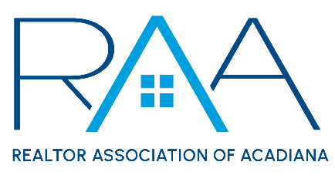

Events Committee Meeting
Friday, February 10, 2023

MINUTES

- Call to Order: Charlotte Dunbar & Ryan Petticrew (co-chairs) – Called the meeting to order at 10 a.m.

- 2023 Events: Charlotte Dunbar, co-chair, announced the confirmed event dates for 2023.
  - REALTOR® Appreciation Day: Charlotte Dunbar, co-chair, reported that REALTOR® Appreciation Day will be held on Thursday, September 14 at the Cajundome Convention Center and that further information will be discussed at a later meeting.
  - Gumbo Cook-Off: Charlotte Dunbar, co-chair, announced that the Gumbo Cook-Off will take place on Wednesday, October 25 inside Parc International and that further details will be discussed at a later meeting.
- Charity Selection
  - RAA Donation Policy: Events Committee members reviewed and discussed the RAA Donation Policy.
  - Charity Nomination Form: Events Committee members reviewed the Charity Nomination Form to determine if changes were needed in order to gather all information needed prior to selections. After reviewing the form, the committee members requested that the following be added:
    - Does this organization have an affiliation with the REALTOR® Association of Acadiana? Please explain.
    - When was the organization established?
    - What is the organization's service area?
    - Please upload a copy of your LLC’s proof of good standing certificate with the Secretary of State.
  - Consideration to recommend at least one charity be from one of the outlying parishes:
A MOTION was made and seconded to include at least one charity organization from one of the outlying parishes withing RAA’s service area. MOTION PASSES
  - How long will nominations be open?
A MOTION was made and seconded that the nomination form will go out in the February 14 edition of the Weekly REALTOR® and that all nominations are due by Friday, March 17. MOTION PASSES
- Voting on Charity Nominations
  - When will charity nominees present? Attendees discussed the presentation and voting process and expressed a need to review nominations before determining which charity organizations will be asked to present.
  - Who gets to vote? Attendees discussed the qualifications to vote on charity selections.
A MOTION was made and seconded that any RAA Member who attends the charity presentation meeting will be allowed to vote in the charity selections.
  - How will the vote take place? Attendees discussed several options on how the vote will take place and determined that an in-person secret ballot would be the best way of conducting this vote.
- Next Meeting
  - Schedule: The Events Committee has asked the RAA Staff to identify a Tuesday or Thursday morning following the March 17 deadline for nomination submissions. Once this date has been identified, RAA Staff will communicate this to all committee members.
  - Affiliate Appreciation: Charlotte Dunbar, co-chair, requested that attendees brainstorm options for Affiliate Appreciation to be discussed at the next meeting.

With there being no further business the meeting was adjourned at 11:04 a.m.

