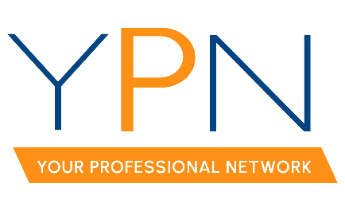

YPN Board of Directors
Wednesday, January 11, 2023

Present: Keisha LeBlanc, Lori McCarthy, Blake Weaver, Ashley Dauterive, Angie Broussard, Dyllan Hawkins, Alyson Schexnayder, Rob Stewart, Casey Oliver
Present Non-Board Members: Allyson Abadie
Absent: Tyler Rush

MINUTES

- Call to Order: Keisha LeBlanc, President: Called the meeting to order at 2:02 p.m.

- Roll Call – Sign-in, Establish a Quorum: Keisha established a quorum had been met.

- Ratification of the 2023 Mentor – Lori McCarthy

A MOTION was made and seconded to ratify Lori McCarthy as the 2023 mentor for YPN. MOTION CARRIED

- Robert’s Rule

Keisha LeBlanc, YPN President, provided Board Members with a cheat sheet for Robert’s Rule and reported that not all rules may apply to our group, but stated that it is important to be respectful of everyone’s time and allow everyone in the group to speak.

- 2023 YPN Events & Meeting Dates

Keisha LeBlanc, YPN President, provided Board Members with a list of confirmed meeting dates and reported that she had also provided a copy of all dates to Chris Meilleur with The Room at Corner Bar.

- February 9th – Morning Buzz
  - Topic: Attendees decided on Strategies for Success in 2023, which will feature 4 industry leaders including a broker, insurance agent, attorney, and a lender.
  - Panel:
    - Ashley Dauterive, YPN Board Member, is reaching out to Stacey Britton, the current AMLA President.
    - Dyllan Hawkins, YPN Board Member, is reaching out to Levi Kastner, insurance agent.
    - Lori McCarthy, YPN Mentor, will reach out to Sara Zuschlag, attorney.
    - Lori McCarthy, YPN Mentor, will be the broker on the panel.

  - Sponsor: Ashley Dauterive, YPN Board Member, will reach out to Antoinette Guthrie with Andrus Boudreaux Complete Title to sponsor.
- March 9th – Morning Buzz:
  - Topic: Attendees discussed possible topics for the March Morning Buzz and decided on March Madness.
  - Panelists: Rob Stewart, YPN Board member, will reach out to Jackie Russo as a potential panelist.
  - Sponsor: Rob Stewart, YPN Board member, will sponsor.

- YPN Committee Suggestions: Attendees discussed potential ways to involve the YPN Committee members and agreed to host a meeting and encourage members to promote YPN events.

- New Business
  - Morning Buzz Sponsorship Amount

A MOTION was made and seconded to increase the amount of Morning Buzz sponsorships to $150 to include a $25 gift card. MOTION CARRIED

With there being no further business the meeting was adjourned at 3:01pm.

