YPN Advisory Board Minutes
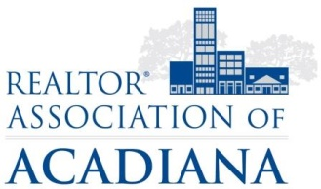
REALTOR® Association of Acadiana
1819 W. Pinhook Ste. 115
Lafayette, LA 70508
RAA Board Room
Wednesday, February 7, 2018

Present: Kyle Bolivar, Tara Bienvenu, Leslie Guillory, Brandon Bradley, Tony Cobarrubia, Leah Thibaut, Claire Disch, Caitlin Hebert, Lynzie Blanchard, Billy McCarthy
Present Non-Board Members: Sara Bourque, Lisa Roy Sheppert

Minutes
Brandon Bradley called the meeting to order at 2:05PM.
A motion was made to approve the Minutes from January. A second was called, all in favor, motion carried.
A motion was made to approve the Amended Morning Buzz Topics for 2018 as follows.
- March – New LREC Property Disclosure with Steven Hebert, LREC Commission, Brandon Bradley with a Title perspective and Claire Disch to provide insight and variables.
- April – Fair Housing – Small Questions, Big Trouble
- May – Social Media
- June – Home Staging – Is it Worth it?
- July – Top Producer Panel Q & A
- August – For Sale By Owner – How do you work with FSBO for your clients?
- September – REALTOR® Safety
- October – CPA & Taxes
- November – Fee’s Fee’s Fee’s – Who Do I need to Pay
- December – Naughty or Nice
A second made, all in favor motion passed.
A motion was made and seconded to table the YPN Trivia Night name. All in favor, motion carried.

Minutes submitted by:

Sara Bourque
Communication/Professional Development Director
REALTOR® Association of Acadiana

