Events Committee Meeting
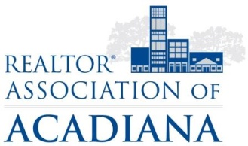
REALTOR® Association of Acadiana
1819 W. Pinhook Ste. 115
Lafayette, LA 70508
RAA Education Room
Tuesday, April 18th, 2017 11:00AM

Present: Cynthia Ahart, Michelle Bernard, Cynthia Beslin, Kelsey Bonvillian, Stacey Britton, Kim Carter, Suzanne D’Ambrosio, Doris David, Amy Davis, Harry Fuselier, Antoinette Guthrie, Ivan Jennings, Dennis Jones, Kristin Malarcher, Joseph Malbreaux, Marilyn McDonald, Kim Meche, John Pitre, Maria Pitre, Caitlyn Hebert, Padgett Richard, Kelly Streva, Leah Thibaut, Victoria Thomas, Angi Trahan, Ellen Weimer, Sara Zuschlag

Minutes:

Antoinette and Dennis called the meeting to order at 11:04AM.

Dennis updated the committee on Affiliate Appreciation Day coming up on Thursday, May 11th from 11:30AM-1:00PM in the RAA Parking lot. He advised the committee El Paso will cater the event next door.

Volunteers are needed for set-up, serving, and tear-down. He asked those willing to volunteer should sign-up on the back table. It was also announced every REALTOR® member should bring a door prize of a minimum of $25.

Antoinette reported the committee tabled the band selection for this year’s Gumbo Cook-off. Discussion was held and a few committee members inquired about Louisiana Red. Marilyn McDonald advised she would contact Louisiana Red to see if they are available and what price they would charge. The band selection would be tabled for next meeting, where the committee will vote.

There was no new business. The meeting was adjourned at 11:23AM.

