YPN Advisory Board Minutes
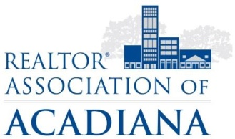
REALTOR® Association of Acadiana
1819 W. Pinhook Ste. 115
Lafayette, LA 70508
RAA Board Room
Wednesday, April 11, 2018

Present: Kyle Bolivar, Tara Bienvenu, Leslie Guillory, Brandon Bradley, Tony Cobarrubia, Leah Thibaut, Claire Disch, Caitlin Hebert, Lynzie Blanchard, Billy McCarthy
Present Non-Board Members: Sara Bourque, Lisa Roy Sheppert
Absent: Leslie Guillory, Tara Bienvenu

Minutes
Brandon Bradley called the meeting to order at 2:07PM.
A motion was made to approve the Minutes from March. A second was called, all in favor, motion carried.
A motion was made to set the sponsorship table price at $200 a table with 20 sponsor tables. A second was called, all in favor motion carried.
A recommendation to table the fall event was made.
The meeting adjourned at 3:00PM.

Minutes submitted by:

Sara Bourque
Communication/Professional Development Director
REALTOR® Association of Acadiana

