YPN Advisory Board Minutes
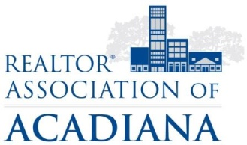
REALTOR® Association of Acadiana
1819 W. Pinhook Ste. 115
Lafayette, LA 70508
RAA Board Room
Wednesday, March 7, 2018

Present: Kyle Bolivar, Tara Bienvenu, Leslie Guillory, Brandon Bradley, Tony Cobarrubia, Leah Thibaut, Claire Disch, Caitlin Hebert, Lynzie Blanchard,
Present Non-Board Members: Sara Bourque, Lisa Roy Sheppert
Absent: Billy McCarthy

Minutes
Brandon Bradley called the meeting to order at 2:03PM.
A motion was made to approve the Minutes from February. A second was called, all in favor, motion carried.
A motion was made to have YPN Trivia Night at Jefferson Street Pub on Thursday, May 24th. A second was called, all in favor motion carried.
A motion was made to have in memory or in honor of Louie Cowen for YPN Trivia Night. A second was called. There were 6 no votes and 2 yes votes. Motion failed.
After much discussion, a recommendation to table the topics of the Summer Series for the next meeting.
The meeting adjourned at 3:07PM.

Minutes submitted by:

Sara Bourque
Communication/Professional Development Director
REALTOR® Association of Acadiana

