YPN Advisory Board
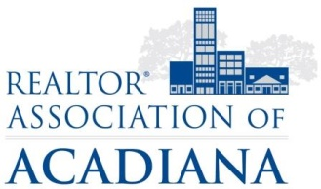
REALTOR® Association of Acadiana
1819 W. Pinhook Ste. 115
Lafayette, LA 70508
RAA Board Room
Wednesday, October 4

Present: Kyle Bolivar, Lynzie Blanchard, Gerren Benoit, Tara Bienvenu, Leslie Guillory, Brandon Bradley, Billy McCarthy, David Gleason, Jacquie Cain
Absent: Jesse Regan
Present Non-Board Members: Sara Bourque, Angi Trahan

Minutes
Jacquie Cain called the meeting to order at 2:07PM.

Billy McCarthy made a motion to approve the Minutes from September. Tara Bienvenu seconded. All in favor, motion carried.

The Board discussed September’s Morning Buzz on REALTOR® Safety as well as the Charity Case social. They felt since they have had such light attendance and with all the events going on in the month of October, Tara Bienvenu motioned to forgo the Morning Buzz for October and start fresh in November with the topic of Business Planning and invite a CPA as a guest speaker, and for the December Morning Buzz the topic will be REALTOR® Etiquette. Gerren Benoit seconded. All in favor, motion carried.

Sara Bourque reviewed the election process with the Advisory Board. Applications will be sent out the following day, and the deadline to turn in the application will be October 20th. There will be 3 board seats available, of those, one affiliate seat. If more than two REALTOR® applications are submitted, YPN will hold an election through electronic ballot.
The Board discussed holding a social at Rhythms on the River when a noted musical guest would be in attendance. The board recommended holding it the first week of November and asking Bayou Title to host the YPN members.

There was no new business. The meeting adjourned at 2:57PM.

Minutes submitted by:

Sara Bourque
Communication/Professional Development Director
REALTOR® Association of Acadiana

