YPN Advisory Board
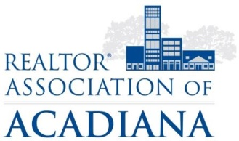
REALTOR® Association of Acadiana
1819 W. Pinhook Ste. 115
Lafayette, LA 70508
RAA Board Room
Wednesday, March 7th, 2018

AGENDA

- Call to Order
- Morning Buzz
- Trivia Night
- Summer Series
- Fall Event
- New Business

